# Chapter 1: Introduction

* 1. **Background of project**

online Bazzar is a web portal where customer can order any product they needed and can access to their cart to see the order quantity and total price for product. In case of deleting order they can easily cancel their ordered product.

The customer can view products details, category and price from anywhere else. To access the system customer needs to signup first and later with valid username and password they can enjoy the shopping online.

The developed application online Bazzar is reliable and as friendlier to their users with less bugs and high performance rate where customers can interact with system effectively. It facilitates people which have busy schedule in their work by diminishing the time required for shopping in market. While developing this system MY SQL for database and PHP for programming are used.

* 1. **Problem statements**

while buying of any product in supermarket customer have to face various problems like transportation expenditure and a most important thing is that they have difficulty to manage time. Although product seller has to face various problems like there is the high chances of data duplication among various customers which leads to the various organizational issues.

The main aim of this project is to serve the customer which are physically challenged and which have too busy schedule on their work. It also reduces the problem like data duplication, standing for hours in market, and reduces cost and time as well. With the development of this system customer can easily view various products and order them as required.

* 1. **Project features**
* customer can sign up and login to access the system.
* Customer can search and order items.
* Customer can delete orders.
* Customer can change password concerning security.
* Admin can do CRUD operations on products
* Admin can manage customer orders.
* Admin can delete products when not necessary.
* Admin can change password when he feels unsecure.
  1. **Aims and objectives of project**

The project online Bazzar is developed to serve the customer for accessing the system from anywhere and at any time. The customer can view the item they needed in reasonable price and order them easily. The listed below points are the aims of the project: -

1. The main aim of the project is to sell and buy the products online.
2. Facilitates those types of people who are physically challenged and who have busy schedule on their work.
3. It saves time and money of customers.
4. Customer data will be managed effectively.

The main objectives for my projects are as follow: -

1. To develop a user friendly system concerning different level age group through which they can easily access the system.
2. Helps to provide day night service to their customer in reasonable price.
3. Provide reliable and secure system to user with the intention of customer data can be protected and managed effectively.
4. It diminishes the data duplication problems in customer information.
5. Customer information on database are also secured.
   1. **Overview of the project**

Online Bazzar is the process of buying and selling of any products as the customer requirement over the internet which facilitates the customer to save their time and money. Now a day this means of shopping is common in every parts of world concerning user needs and requirements with less bugs, concerning reliability and with better performance the system “Online Bazzar” is developed.

Online Bazzar is the web based application where customer can search any product they needed with proper login into the system. The user information and data will be kept secure and managed properly. Regarding admin responsibility, he can add, update and delete products additionally customer order and product details are maintained as well.

# Chapter 2: Analysis

**2.1. Introduction**

Before developing a project, the earliest stage is to appreciate what that system prerequisite to be. Analysis is the initial phase which helps to gather various information’s in order to understand its nature or to recognize the basic fundamental features. While doing analysis of the certain project it helps to know the system performance. The purpose behind analysis is to find necessities which recognize and sort out the various information need which encourages to get best objectives. Furthermore, the aspect of the current information system is also described.

**2.2. Information gathering techniques: -**

It is a repeated process which are utilized to make and sort out data crosswise over various types of sources through different means. Here I have used some of the information gathering techniques which are as shown underneath: -

Brainstorming: -

This procedure is utilized for getting a summary of entire project records. All thoughts are made with the help of facilitator through an open exchange and mass gathering systems. For the most part, method of conceptualizing should be possible amid a booked gathering with mates, singular conceptualizing, or even at a casual gathering.

Interviews: -

Interview is a formal way of information gathering in which two or more than two people are communicated face to face or any source of media. For getting different idea and opinion for this project from different people interviews plays a vital role to accumulate the information in a reasonable manner and in addition it results the sustainable information’s from the different candidates.

**2.3. Feasibility study**

A feasibility study is a methodology of analyzing the suitable component of the project including financial, specialized, legitimate, and scheduling consideration to decide the conceivable outcomes and likelihood of finishing a project effectively. Some of the feasibility analysis are demonstrated below: -

* Technical feasibility

It evaluates the complete investigation of the project as far as software, hardware’s, fields, projects and strategies. It is a powerful tool for long term plan and trouble shooting.

* Schedule feasibility: -

It describes the time to be allocated on completing the entire project and characterize as the likelihood to finish inside its schedule time limits. at that point its timetable possibility is evaluated as high.

* Economic feasibility

Basically, it determines whether the project is cost feasible or not and checks the projects running over the budget or out of the budget. It helps to calculate by analyzing the costs and revenues for the certain project to be developed.

* Resource Feasibility:

It incorporates questions in regards to time required to finish the task, type and measure of assets required and subordinate components. So it deals with ideal use of the resource accessible.

**2.4. Object oriented analysis**

Here in this project object Oriented methodology is used because it is system development approach empowering and encouraging re-utilization of parts. Through the adoption of this methodology, higher profitability, lower support cost and better quality can be accomplished. Additionally, it is easy for understanding and diminish the complexity of software object models.

**2.5. Development methodology**

The product will be developed by using the software development life cycle process or waterfall model which can be defined as the approach with sequential steps for logical progression and each phase have to be complete before moving to next phase.

The steps of waterfall model are described below: -

* Requirement analysis: -

It is the initial phase of development in which the customer functional and non-functional requirements are analyzed to produce system models which may help on the effective development.

* System design: -

In this phase of development, the requirements which are analyzed in the first phase are considered and a relevant design for the system is produced.

* System implementation: -

In this phase of development, the small product is generated by considering system requirements and design further it will be combined on the full workable system.

* System testing: -

In this phase of development, the workable software is tested for its functionality which is also called unit testing. The software should be tested well for increasing its reliability and with the intention that no bugs will be seen in the future.

* Deployment: -

In this phase the highly quality assurance product is deployed to customers to collect their various feedback on the system requirements.

* Maintenance: - This phase generally occurs after the successful deployment of the project in which changes on requirements are done if needed and maintenance of system is done

Requirements analysis

System design

System implementation

System testing

Deployment

Maintenance

**2.6. Pitfalls and merits of the project**

Merits: -

* it facilitates to physically challenged peoples and the individuals which have busy work on their schedule
* It is easier to use and more user friendly
* It facilitates people to order the necessary item from anywhere else

Pitfalls: -

* it does not facilities customer by providing online payment system.
* It needs internet to access.
* Lack of some advanced functions.

**2.7. System Requirements Specification: -**

A system requirement specification is a report or document set which provides detail information about features and behavior of a system. Basically it is profitable for system development because it minimizes the amount of time and reduces the cost to develop a complete project. It also fills as an understanding among the designer and the customers for whom the system is being created. It provides complete description of a functionality and specifics of the website “Online Bazzar”.

* + 1. **Functional Requirements**

Basically functional requirements are the necessities which specifies what the system should do. The core functionality of the whole project is described in the presence of functional requirements and consolidates various data and functional process necessities

|  |  |  |  |  |
| --- | --- | --- | --- | --- |
| **Id** | **Title** | **Description** | **Rational** | **Dependencies** |
| FR1 | Login for Admin | Admin should use authorized username and password for login into the system. | For accessing the system and view various product. | N/A |
| FR2 | Add Categories | it can be used to categories the various online product by system admin. | It makes easier to customers to select the items by their category | N/A |
| FR3 | Add items | The various newly information about items were added to the system by admin. | To add various modern and fashionable items. | FR2 |
| FR4 | Update/Edit items | The newly product to the system were edited and updated. Admin update and edit system database. | To edit and update the modern and fashionable product. | FR2,FR3 |
| FR5 | Delete items | Admin can delete the old fashionable items and information related to the system. | To remove the unnecessary information | FR2,FR3,FR4 |
| FR6 | Order management | Various product order by customers were managed by the admin in the system. | Various customer online orders were viewed in the system. | FR2, FR3, FR4 |
| FR7 | Logout | Admin can easily log out of the system from admin panel of the system. | To get out of the system. | FR1 |

.

|  |  |  |  |  |
| --- | --- | --- | --- | --- |
| **Id** | **Title** | **Description** | **Rational** | **Dependencies** |
| FR1 | User Sign up | User should share some personal information to sign up to the account. | To signup user in the system | FR2 |
| FR2 | User login | User should use authorized username and password to login into the system. | It verifies the authorized user to access the system. | FR1 |
| FR3 | Views items | User will view various updated and fashionable items. | To view various shopping items | N/A |
| FR4 | Online ordering | User can easily order any items online through the system. | For selecting the various items required by the customers. | N/A |
| Fr6 | Delete orders | Customer can delete order in case of not necessary. | To charge the cost of items | FR4 |
| FR5 | Logout | After selecting various required items users will be able to get logout of the system. | To end the process of the user. | FR2 |

* + 1. **Non-functional requirements:**

These are any requirements that can't be arranged into Functional, Data or Process necessities. Non-functional requirements reflect how the system need to function.

|  |  |  |  |  |
| --- | --- | --- | --- | --- |
| **Id** | **Title** | **Description** | **Rational** | **Dependencies** |
| NFR1 | Performance | Website should be able to handle various customers at a time and will have expedient response rate. | To improve the speed of information provided to numerous customers. | NFR1 |
| NFR2 | Availability | Items at the specific time should be provided to the customers as their demand. | It should be needed to provide demandable product at a pointed time. | NFR3 |
| NFR3 | Reliability | System should be authentic, accurate and steadfastness. | It helps to increase the organization performance and accuracy level. | NFR2 |
| NFR4 | Maintainability | System should be maintainable on daily basis if any fault or bugs arise. | Maintaining further is an easy technique. | N/A |
| NFR5 | Portability | The website should be mobile accessible in other words ca be fit on any device at a time. | It helps to make system easier to use to customers. | NFR2 |
| NFR6 | Security | System ought to be secured from various malwares, viruses and attackers. | To keep secure website from unauthorized access. | NFR1 |
| NFR7 | Usability | The system should be understandable to users and become user friendly. | Interest of customers will be high if it is simple to use. | N/A |

**2.8 Prioritization: -**

Simply the prioritization is the method in which a set of items are ranked with regard to their importance. It plays vital role in decision making and to gain the specific goals. It separates the various tasks according to their importance in current time and providing extra time, consideration and vitality. I have used Moscow strategy in this project. The importance regarding prioritization are as follows:

• It helps to increase productivity and reduce stress.

• It encourages people to get clear on their goals and vision.

• It provides the possible feedbacks and keeps motivated

**2.8.1. Moscow (Must, Should, Could, Wont) prioritization: -**

Moscow method of prioritization is a popular strategy for requirement management which starts from the DSDM.

**Must have: -**

Must have are items in a system which plays a vital role in order to move forward and these requirements must be fulfilled. With improper implementation of these requirements project leads to unsuccessful.

**Should have: -**

These items are not more important as to move forward and to be fulfilled but in absence of these items a higher level of pain can occur in a project.

**Could have: -**

These categories items are commonly those items which are desirable in the project but not highly important. If the project is running over the specific time these requirements will be erased from the system.

**Won’t have: -**

It can be represented as those items which were recognized to be desirable or profitable, yet will not be implemented in current release. In future they might be taken as the part of the system development.

|  |  |  |
| --- | --- | --- |
| **ID** | **Functional Requirements** | **Moscow** |
| FR1 | Login for admin and user | Must have |
| FR2 | Customer Sign up | Must have |
| FR3 | Add, customers | Should have |
| FR4 | Add items | Must have |
| FR5 | Search items | Should have |
| FR6 | Update items | Must have |
| FR7 | Delete items | Should have |
| FR8 | Add categories | Should have |
| FR9 | Payment process | Could have |
| FR10 | Order management | Should have |
| FR11 | Customer care | Won’t have |
| FR12 | Feedback box | Won’t have |
| FR 13 | Password changing | Should have |
| FR14 | Logout | Must have |

|  |  |  |
| --- | --- | --- |
| **ID** | **Non-functional Requirements** | **Moscow** |
| NFR1 | Performance | Could have |
| NFR2 | Availability | Could have |
| NFR3 | Reliability | Could have |
| NFR4 | Maintainability | Should have |
| NFR5 | Portability | Should have |
| NFR6 | Security | Should have |
| NFR7 | Usability | Should have |

**2.9 Architecture:**

It is fundamentally characterized as the art and study of designing and building structures, or sweeping get-together of structures, concerning aesthetic and practical criteria. It is also known as the foundation for system development and usually called blue print of utilization although it consists each and every single element.

**2.10 System Architecture:**

System architecture is dynamic, conceptualization-situated, around the world and focused to achieve the mission and life cycle ideas for system development. It designates expected usefulness to hardware's and programming portions. It is basic since abnormal state decisions impact an undertaking for a long time.

There is the utilization of MVC design pattern in system development which basically represents the Model, View and Controller.

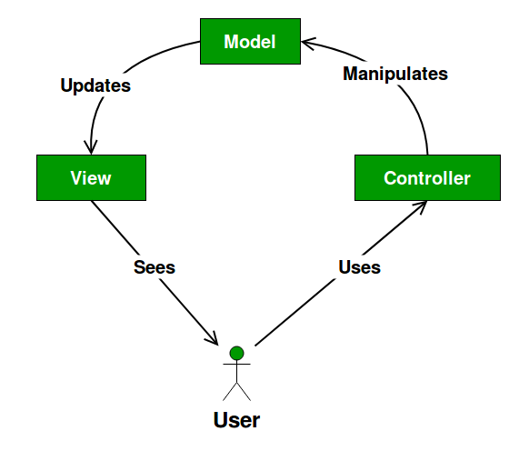

Fig: MVC design pattern

**Model:**

It reflects the data and real world things and plays vital role in describing the essential components of the system.

**View**

It helps to send the user action to the controller and represent the model data.

**Controller**

The controller gives model information to the view, and deciphers client activities. It's the minds of the application, and ties together the model and the view.

**2.11 Use Case Diagram:**

Use case is a methodology which describe the users of the system and their interaction with the system. It plays an important role in designing a system from end users perceptive and describe the relationships between actor, use case and system. The purpose of the Use case diagram is demonstrated below: -

• It helps to specify the requirements for the system development.

• It provides validation to system design.

• It helps to produce test cases and for running implementation.

Some basic symbols are demonstrated below which are used as use case as system: -

**System**: -

Generally, it is denoted as rectangle shape which helps to draw the system boundaries in use cases. The symbol for use case system is below: -

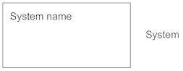

**Actor**: -

Actor is defined as anything which interact with the system. The symbol for actor in use case diagram is demonstrated below: -

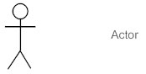

**Use Case**: -

It is denoted by the oval shaped and it shows the importance of the actor. The sign of indication for use case is demonstrated below: -

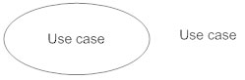

**Relationship**: -

We can mark relationship between use case and actor by arrow sign either uses or extends among the use cases. The sign of indication for is demonstrated below: -

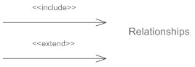

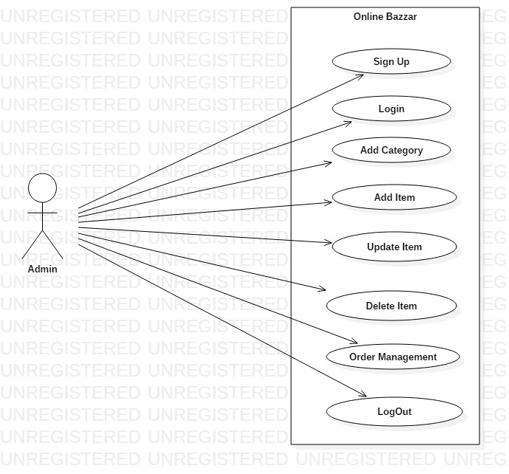

Fig: Use case diagram of Admin for online Bazzar

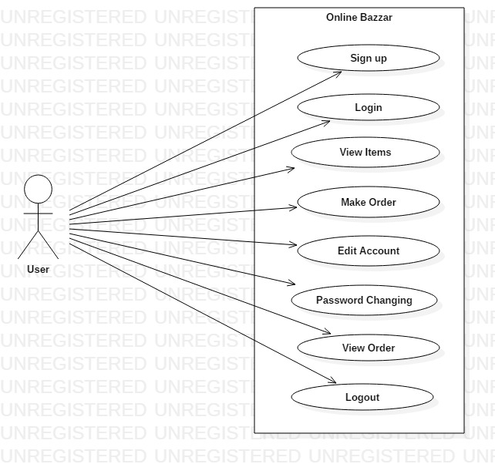

Fig: Use case diagram of User for Online Bazzar

**2.12 Natural Language Analysis: -**

Natural language analysis is the capacity of various programs for understanding human language. The scenario relating to this project “Online Bazzar “is demonstrated below: -

“Online Bazzar” is a web based application which provides their customer a relevant service. Generally, it is the process of purchasing the desirable items online through internet. Buying the product over internet has taken popularity now a days and many people find it comfort and easy means of buying the different products which diminishes the time taken mostly for the people who are busy on their daily life. It facilities its customers by making a business word smaller and relevant simply by clicking a mouse button any one can order the desirable item they view in the system.

After signup by the various customers in the proposed system they are able to choose the various items from category. The system facilitates the number of customers can have logged in at the same time and visit the item category and see various products. Customers can view the various products after login to the system they can order the desirable items through online system. The detail of the website is also illustrated if any customer wants to know about the system or organization details. The various items were updated by the admin of the proposed system. The system facilitates its customers by adding different modern and fashionable items. They can be updated and deleted by the admin on daily basis if any new products were seen the market.

The main objectives of Natural language analysis are to acquire the list of candidate classes, relationship between them and their behaviors. It helps to increase the efficiency of the proposed system and reduces the data duplication. After doing NLA process on certain scenario the list of candidates classes, their attributes and behaviors are enlisted below: -

|  |  |
| --- | --- |
| Classes | Functionality |
| Sign Up, Login, Items, Customers, Order, Admin, items | Customer Sign Up, Customer Login, Ordering Items, Selecting Product, Admin login, Update bio, Add items, Update items, Delete items, view Items, Order view, Customer View. |

**2.13 Initial Class Diagram:**

It is a kind of static structure diagram that portrays the structure of a system by demonstrating the systems classes, their attributes, operations and the connections among objects. The initial class diagram of the system “Online Bazzar” is demonstrated below: -

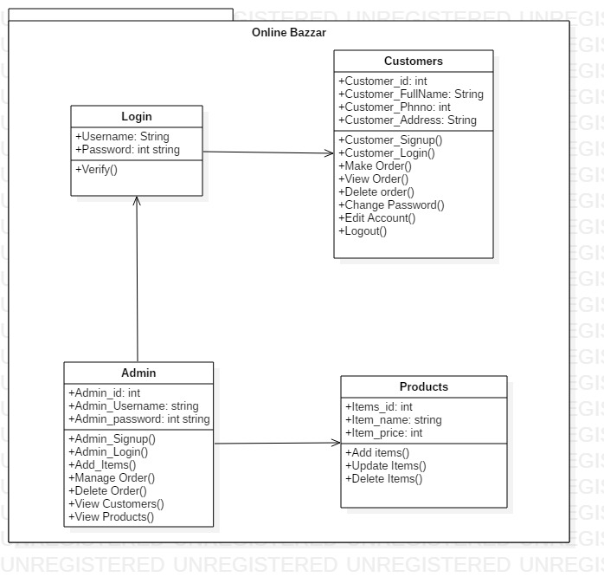

Fig: Initial Class diagram for “Online Bazzar”

# Conclusion: -

In this phase of analysis there is the utilization of the Moscow Prioritization which specifies the functional requirements of the projects. Use of use case diagram illustrates the relationship between actor and the system. beside this functional and non-functional requirement are specified. Lastly including all the above analysis is successfully completed.

# Chapter 3 Design

**3.1. Introduction**

Design of the project is one of the essential stage which leads the project to achieve its goals and explains how the requirements laid out in the functional requirements are performed by a system. Similarly, it facilitates to provide the basic ideas to test the specific requirements, setup setting and provides reviewing of codes and functions.

**3.2. Tools**

The specific tools which are used to develop a complete website “online Bazzar” are as listed below: -

* Integrated development environment = Sublime Text
* Database Design = MYSQL
* Class diagram, Use case diagram, Activity diagram and sequence diagram= Star UML
* Entity relationship diagram= Visual Paradigm

**3.3. Structural Model**

Basically it involves the data flow diagram and class diagram and shows the relationship among various object and ways of communicating. It ensures that the relationship of a system to the extent the portion which help to build up their structure and association.

**3.3.1. Class Diagram**

A class diagram shows the relationships between various classes and illustrates the structure of the whole system. The advantage of using class diagram is: -

1. It provides a complete overview of the whole project to system developers before implementing the codes.

The basic notations used while making class diagram of the project “Online Bazzar” are demonstrated below: -

* Class: - It shows the effective approach from the objects, a group of people and their views: -

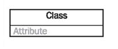

* Generalization: - It is denoted by arrow sign showing relation between various classes.

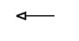

* Association: - It represents the object relation of one class to another class and denoted as: -

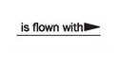

* Aggregation: - It is a specific factor of association consist of diamond shaped arrow.

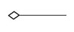

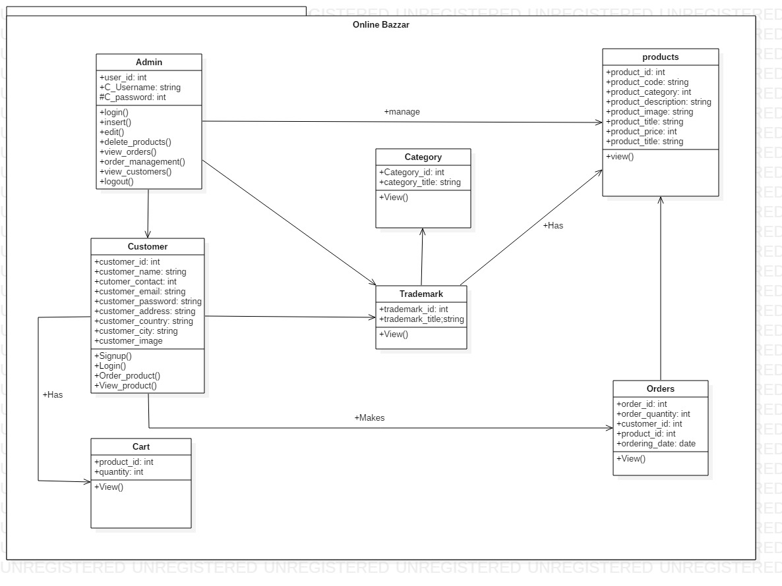

Fig: Class diagram for “online Bazzar”

**Justification:**

The above illustrated class diagram shows the interaction between various classes and represents the state of an object of the class. Here admin can manage products and product order as the need of various customer and the product category.

**3.3.2 Data Flow Diagram:**

DFD is the graphical representation of the flow of data in a certain system and describes the procedure which is engage with a framework to exchange various related data from input to system storage and helps to gain suitable report of the project.

The notation/symbols used while making data flow diagram of my projects are: -

* Entity: - It is also called source or terminator which is used to generate and expend data. It is denoted by the symbol: -

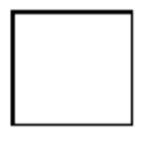

* Process: - simply it is an activity which is used in data transformation and changing data flows. It is denoted by the symbol: -



* Data store: - It is used for data influence for further access and did not perform any action. It is denoted by the symbol: -

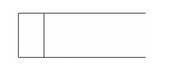

* Data flow: - It is used to represent the interaction between various entities, data stores and processes. It is denoted by the symbol: -

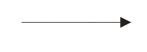

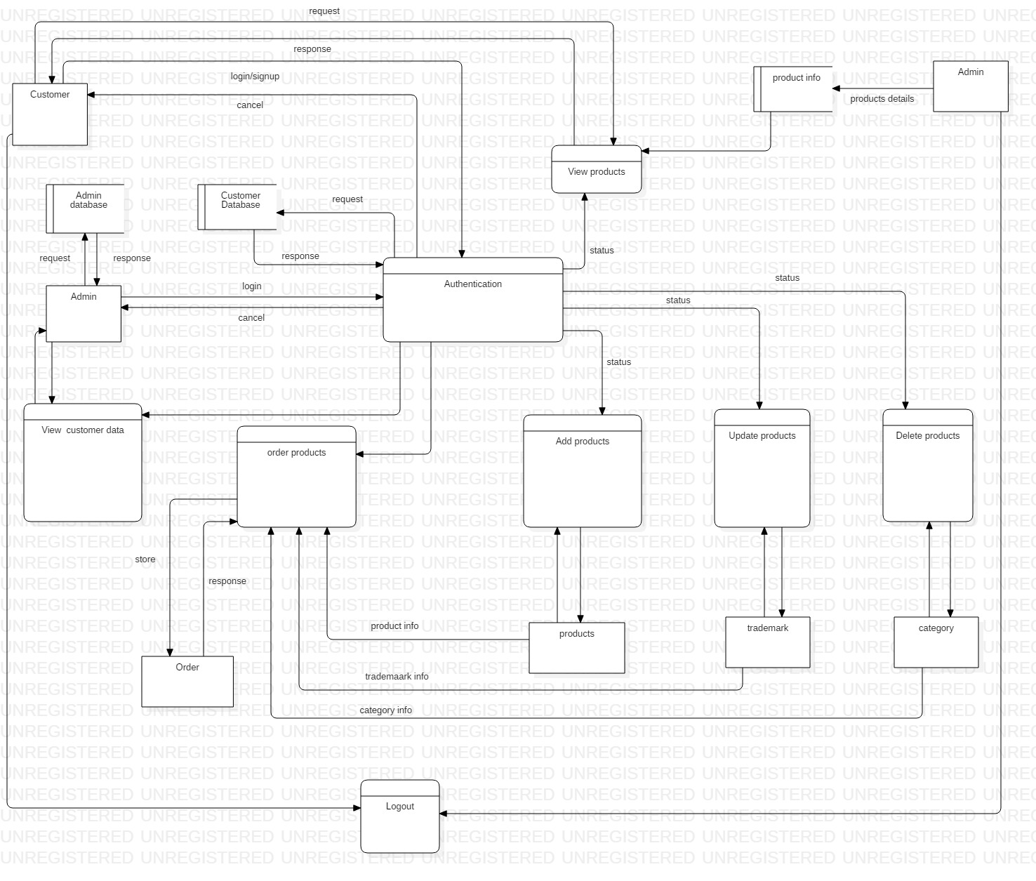

Fig: Data flow diagram for “Online Bazzar”

**Justification:**

The data flow diagram illustrated above provides detail information on describing system boundaries. The data is flowed from one entity to another i.e. after successful login of admin he can add, update and delete products and delete customer data. Here the flow of data from customer can order necessary items. In this way it is easier technique to understand the system.

**3.4. Behavioral Model**

It is the dynamic behavior of the system i.e. strong relation between various object to make a specific system. It facilitates to indicate what occurs and what should happen when a system reacts to an improvement from its condition.

In this step of behavioral model, the activity diagram and sequence diagram is used to show the strong relation between the various objects. The advantage of using behavioral model are as follows: -

* The system will be cost effective.
* It facilitates to meet all the requirements of the system.

**3.4.1. Activity Diagram**

It describes the dynamic aspects of the certain system and consider the flow of one activity to another activity which describe the system behavior. It regards as an essential tool for system developer because they are user friendly among various diagrams.

The basic notations used while making the activity diagram of the system are as below: -

* Action/Activity: It is rectangle in shape and shows non-separable object action. It is denoted by the symbol: -

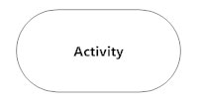

* Control flow: - It represents the transformation of the one activity to another. It is denoted by the symbol: -

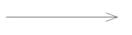

* Initial mode: - It represents as the starting step for any activity diagram and denoted by the symbol: -

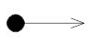

* Final mode: - It represents as the final state for any activity diagram and denoted by the symbol: -

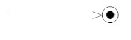

* Decision Mode: - It is represented as the diamond shape and used for moving to next activity. It is denoted as: -

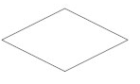

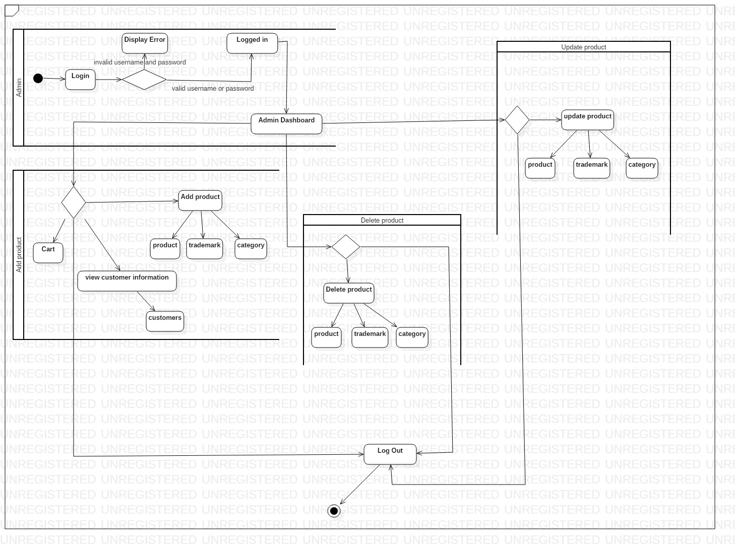

Fig: Activity diagram for Admin of system “Online Bazzar”

**Justification:**

Above activity diagram for admin shows the flow of data from admin dashboard to various activities. The diagram represents the activities of admin in system development and maintenance by adding products, deleting unnecessary customer data and makes system easy to understand.

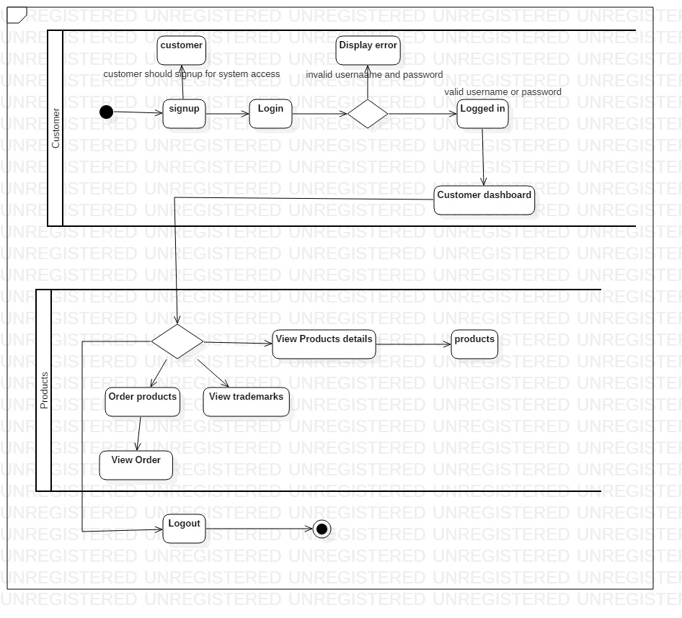

Fig: Activity diagram for customer of “Online Bazzar”

Justification:

Here after successful authentication of user the data is flowed from customer dashboard to various actions like viewing product details, ordering product and finally the customer can logout of the system.

**3.4.2. Sequence diagram**

These are communicating diagrams which Detaille explains how the task should be performed. It is also known as time Centre diagrams because it helps to demonstrate the request of collaboration outwardly by utilizing vertical pivot of diagram to show time.

The basic notation used while making the sequence diagram of “Online Bazzar” are as follows: -

* Synchronous message: - It is represented as arrow sign and needs specific response before interacting.



* Reply message: - Basically it is a reply for certain operation or action and denoted as: -

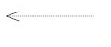

* Self-message: - It is a message in which object sent to itself and denoted as: -

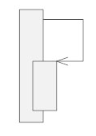

* Lifeline: - It shows the interaction of every instance and denoted as: -

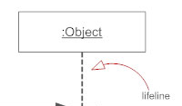

* Found message: - It is the message from unrecognized recipient.

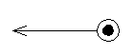

* Lost message: - It is a message sent to unrecognized recipient.

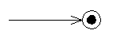

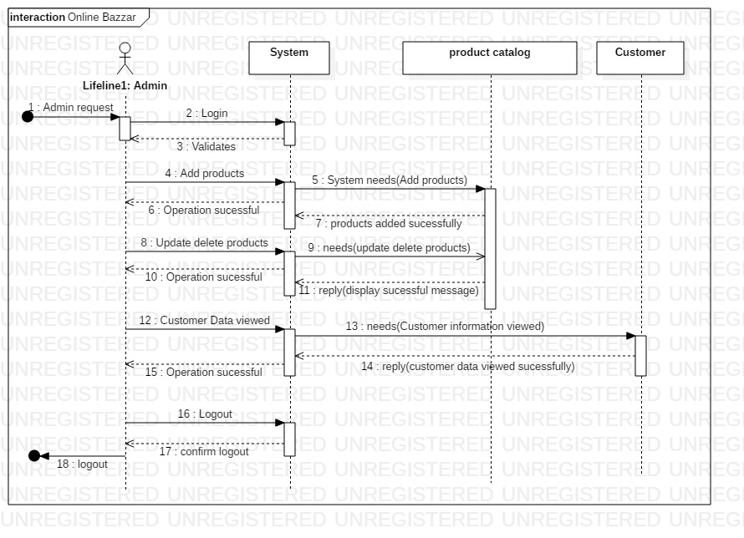

Fig: Sequence diagram for admin of system “Online Bazzar”

Justification:

The above sequence diagram for admin shows the architectural problems earlier as the admin is authenticated successfully there is the flow of data as shown by arrow sign and the message is replied by certain system.

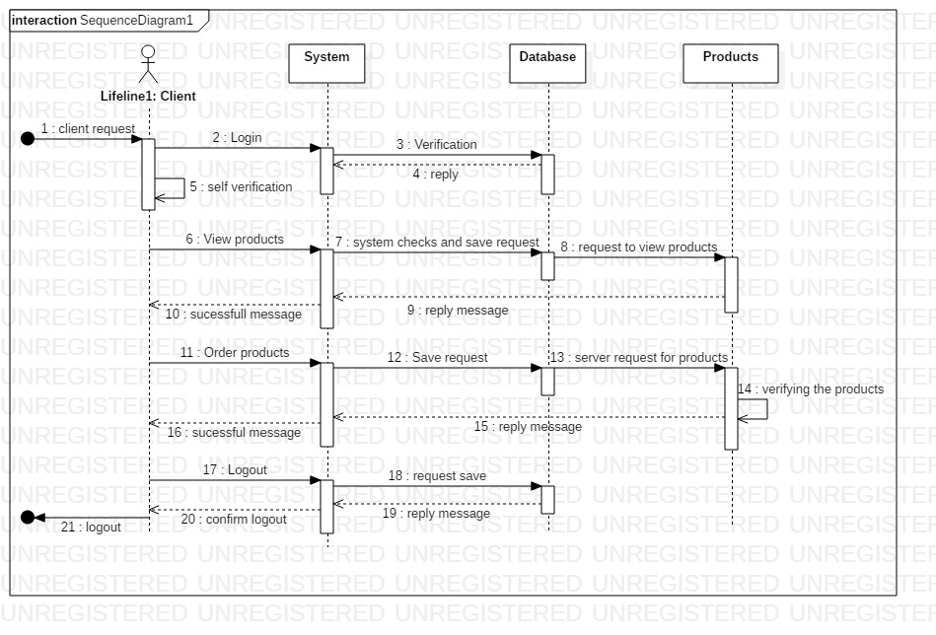

Fig: Sequence diagram for customer of “Online Bazzar”

Justification:

After successful login of client, he/she wants to access the system like ordering products, viewing products then the system checks the database whether it exist or not. The arrow sign with doted circle is the end point for the customer i.e. logout.

**3.5 Database Modelling**

It can be defined as the data modelling technique through which the structures of the database are represented along with relationships and constraint. Here ER diagram is used below for data modelling.

**3.5.1. Entity Relationship Diagram**

It can be also indicated as the entity relationship model which is the graphical representation of the entities and relationship among various objects, events and concepts in a certain project.

The basic symbols used in developing ER diagram are as follows: -

* Entity: - It is rectangle in shape and used to store information about various objects.

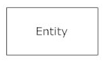

* Connecting lines: - It is used to manage the relationship among various entities by connecting different entities. The connecting lines which are used are as follows: -

1. One to one relationship: -

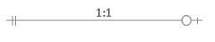

1. Many to one: -

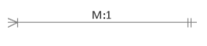

1. Many to many: -

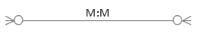

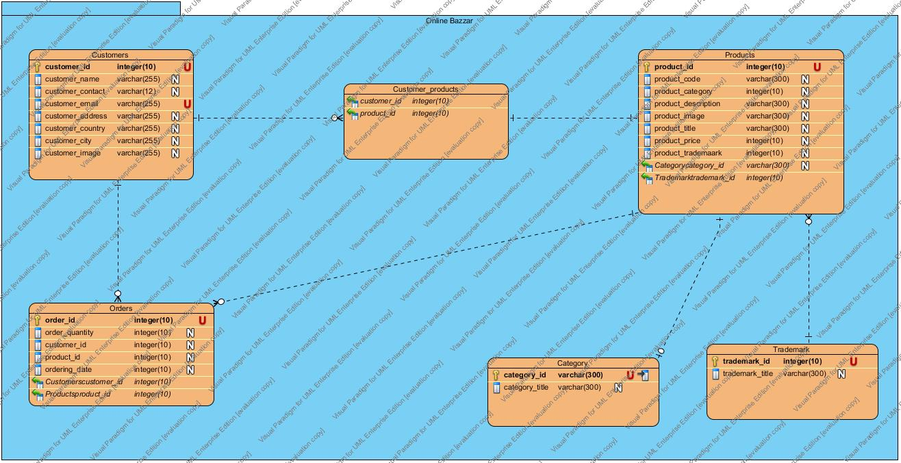

Fig: Entity relationship diagram for “Online Bazzar”

**Justification:**

In above entity relationship diagram the relation between various entities is represented. Here customer can order one or more product and one product has different category. Product is directly related with their trademark. Order is directly related with customer and product because one customer can order various products.

**3.5.2 Data Dictionary:**

It is the process of arrangement of various data, object and items details in a data model or consist of data about database. Some of the advantages of using data dictionary are: -

* It provides effective and understandable information about database.
* It helps to track any disorder by providing specific details.

Here some of the tables are demonstrated below: -

* **Product table: -**

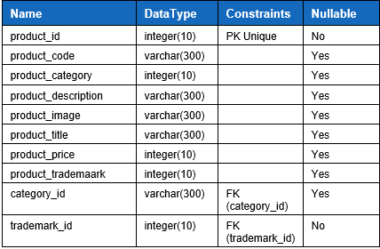

* **Customer table: -**

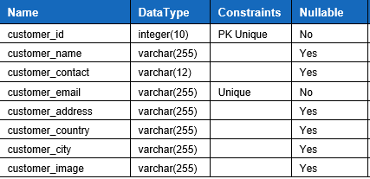

* **Customer_Product table: -**

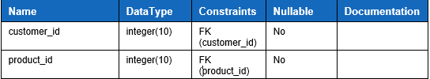

* **Trademark table: -**

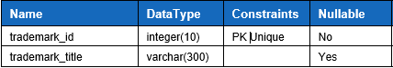

* **Category Table: -**

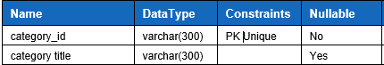

* **Order table: -**

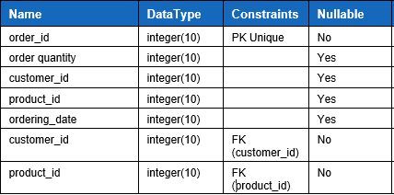

**3.6. UI Design**

User interface design are the important to any system development because the whole design of the system will be meaningless if the customer did not find it easier and user-friendly. Here are some benefits of using UI design in the project: -

* It makes system easier to use and makes more attractive.
* It helps to increase company reputation and customer level of confidence.
* It will diminish the extra cost on regular maintenance of the system.

**3.6.1 Prototyping**

prototyping is the fractional execution of an item communicated either physically or logically with every single outer interface introduced. Some of the benefits of prototyping are as follows: -

* It facilitates by reducing time, cost and ensure product quality.
* It will identify the system requirements and increases user involvement.

Here, I have used Balsamiq application prototyping for the system which are as listed below: -

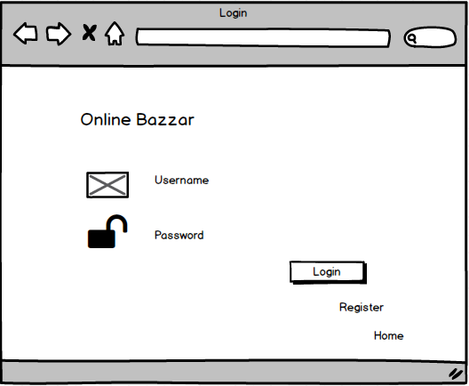

Prototype: Login form for customer

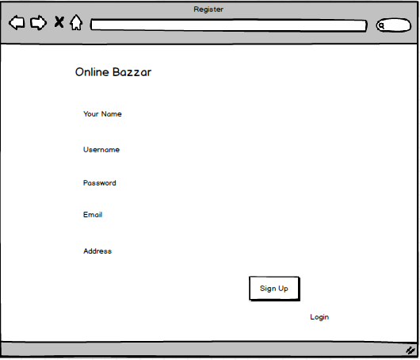

Prototype: signup form for customer

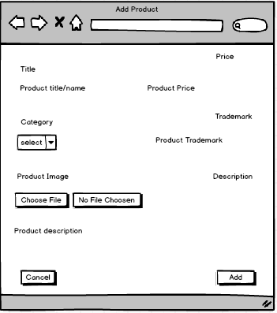

Prototype: Add product for admin

# 

# Chapter 4: Implementation

**4.1 Introduction**

It is the third phase of software development process in which a plan, design, techniques, thought, model, standard developed for software development are converted into real working software concerning user needs and requirements. The codes and UI are listed below in appendix.

**4.2 programming language**

Programming languages a can be defined as the computer languages which are commonly used by developers to create software products. With the flow of time various high level and low level programming language are developed some of them are Ruby, PHP, Java, C#, C, C++ etc. in comparison to others high level languages are more user friendlier to developers.

Similarly, I have utilized core PHP programming language to develop my project. Core PHP indicated authentic PHP utilizing to develop any of the web based applications. It facilitates developers through working with no additional library, to reservoir various information in database MYSQL database is utilized.

**4.3 Development environment**

It can be illustrated as any tool or arrangements of procedures that can be utilized for the development of any products. In other word it is also known as physical environment. The procedures and apparatuses are facilitated to programmers with the intention of providing systematic interface and helps in developing process such as coding, tests etc. some of the examples of development environment are sublime text, Microsoft visual studio, visual online, NetBeans etc.

Sublime text is utilized as the specific tool for my project development. It is adaptable with the goal that it is anything but easier to utilize and available free of cost. The core PHP programming language with MVC design pattern are utilized for system development.

# Chapter 5: Testing

**5.1 Introduction**

Testing can be defined as the action to verify whether the genuine outcomes coordinate the normal outcomes and guarantee the product is bug free. The main purpose of testing strategy is to meet the user requirements after software deployment.

The types of testing method I have used in my project are as described below: -

* + 1. **Black box testing: -**

It is a software testing strategy in which internal structure, design of a product is verified without understanding the code or internal structure. The tester is unknown to the system. The image for black box testing is demonstrated below: -

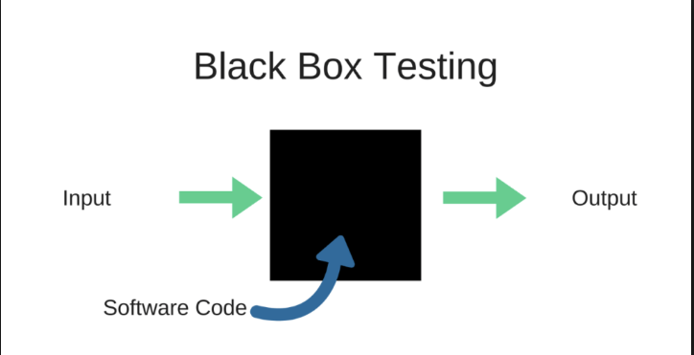

* + 1. **Test plan: -**

Here below there are some activities which has been tested significantly and a document is created. The test case table for black box table is shown blow: -

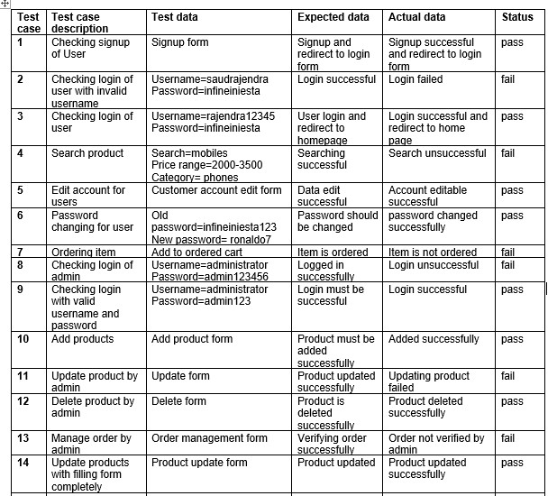

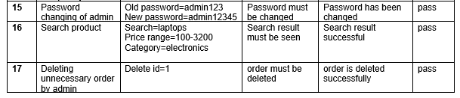

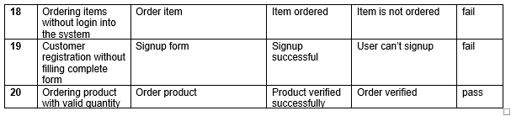

**Test case:1**

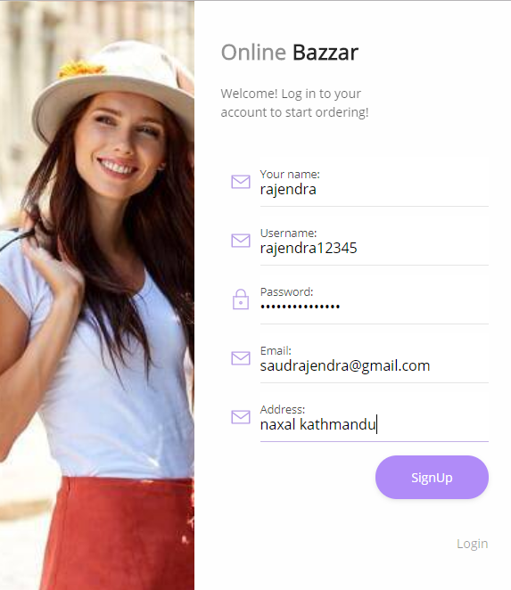

***Fig: signup successful and redirect to login form***

**Test case:2**

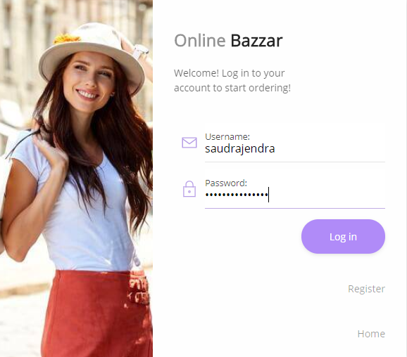

***Login with invalid username***

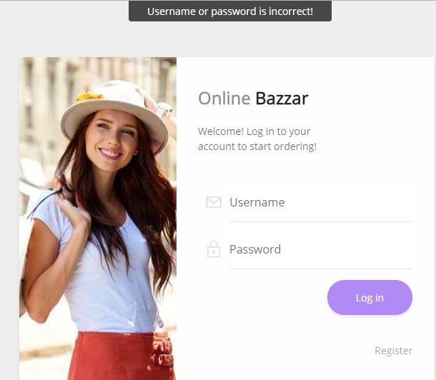

***Fig: customer login failed***

**Test case:3**

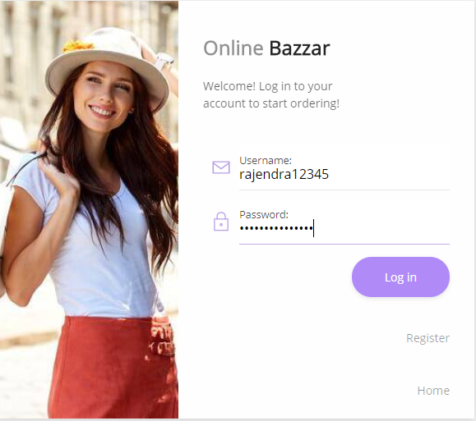

***Fig: login successful with valid username and password***



***Fig: home page for logged in users***

**Test case:4**

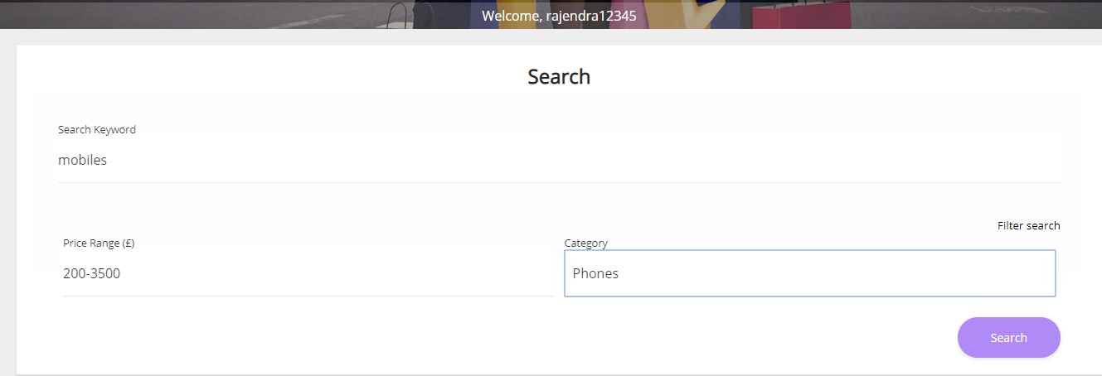

***Fig: product searching for users***

As the needs and requirement of the customer there is no any product is added to the system by admin so the searching result for customer is failed.



***Fig: product not found***

**Test case:5**

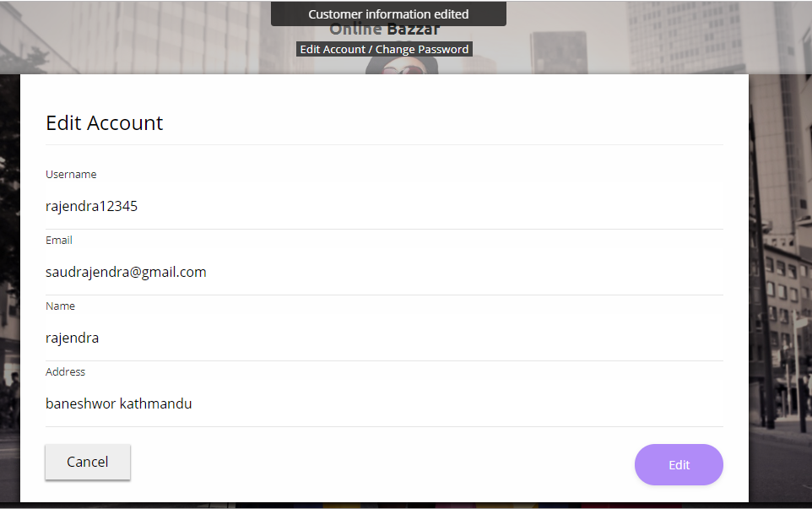

***Fig: customer data edited***

**Test case:6**

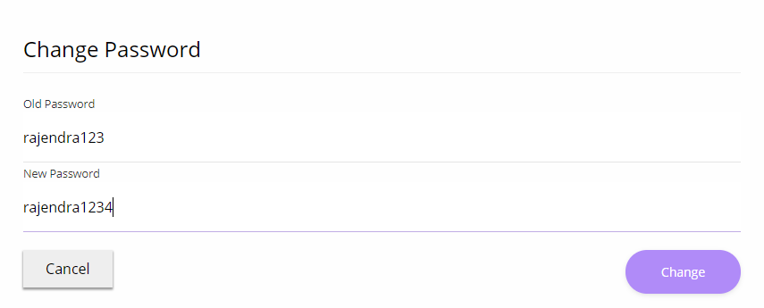

***Fig: password changing form for customer***

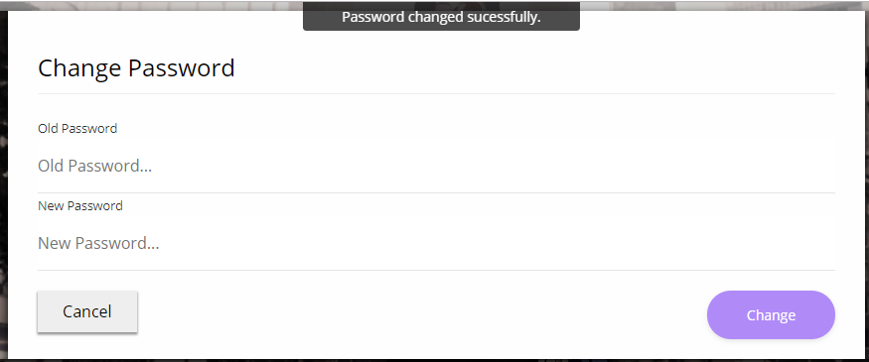

***Fig: password changed successfully***

**Test case:7**

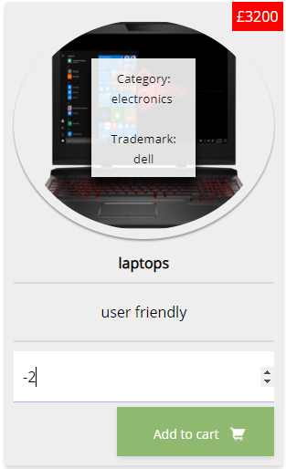

***Fig: ordering item***

The item which is ordered by the customer is not verified because the quantity ordered in in negative marking so the order verified false.

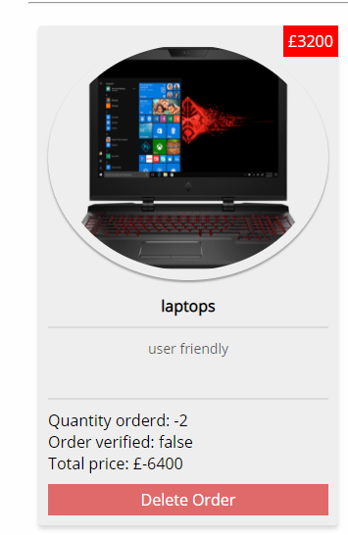

***Fig: ordering item is not verified***

**Test case:8**

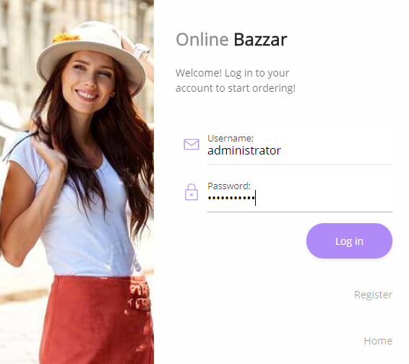

***Fig: log in form for admin***

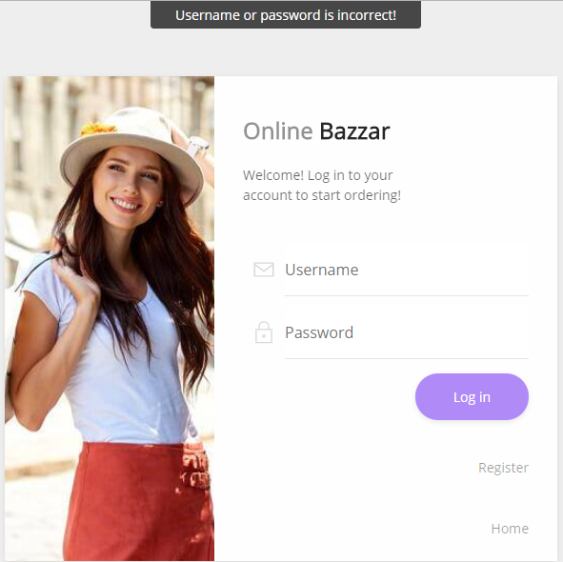

***Fig: login unsuccessful for admin***

**Test case:9**



***Fig: Admin login with valid username and password***

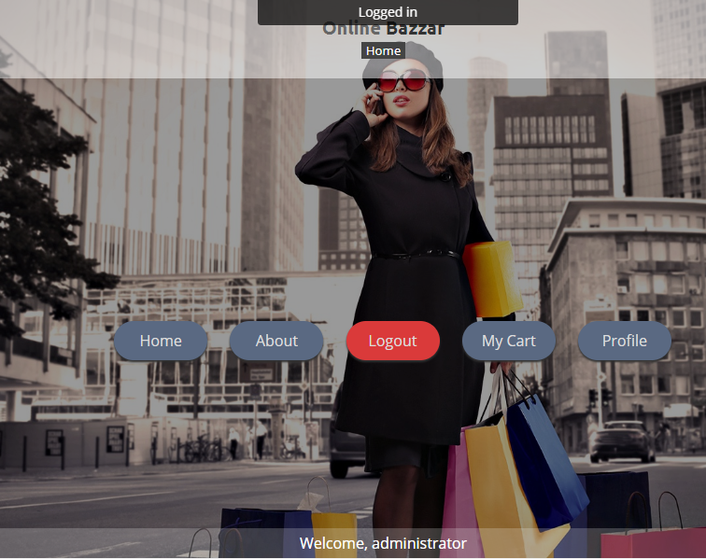

***Fig: successful login of administrator***

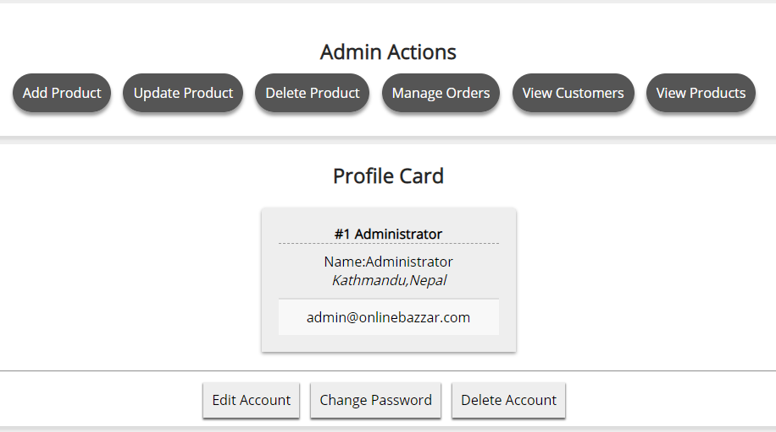

***Fig: Admin actions.***

**Test case:10**

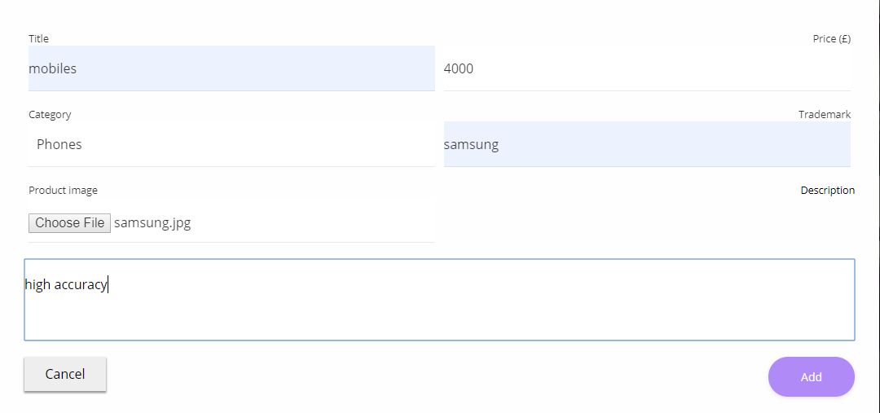

***Fig: add product form.***

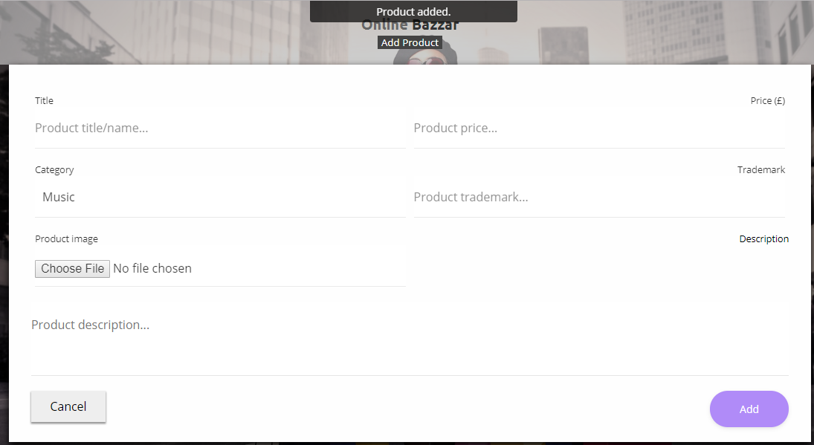

***Fig: product added by admin successfully.***

**Test case:11**

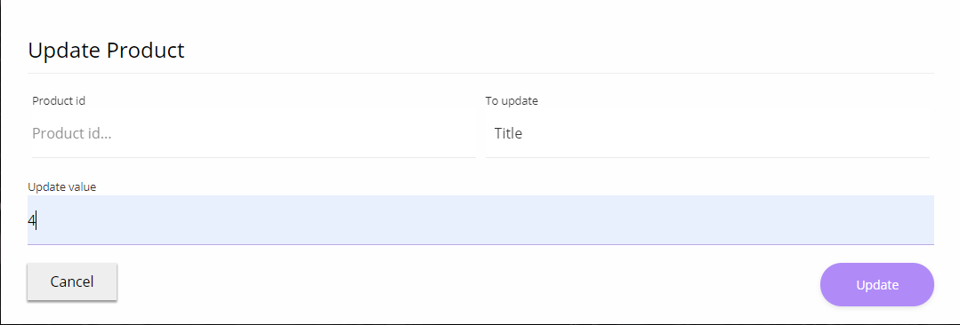

***Fig: product update form for admin***

Here there are some missing characters to fill up the form so the product is not updated

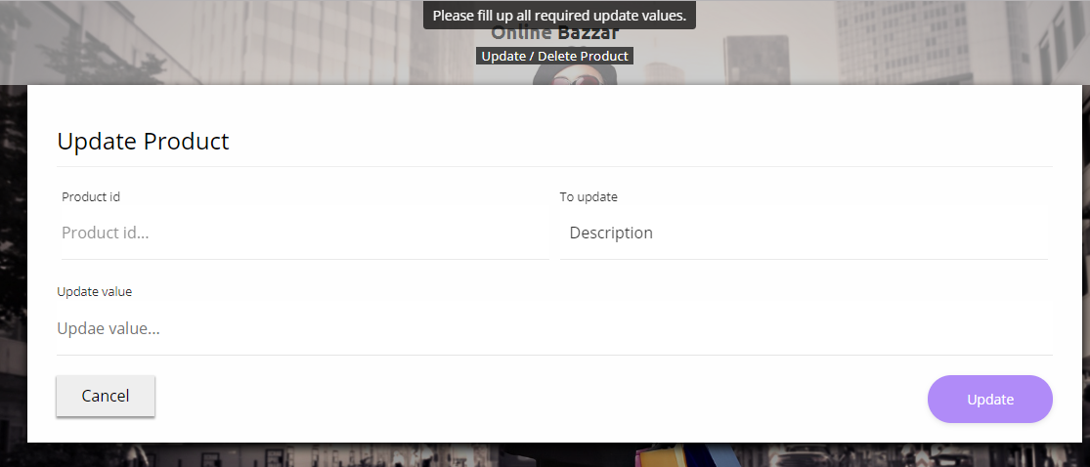

***Fig: message is seen to fill up all values***

**Test case:12**

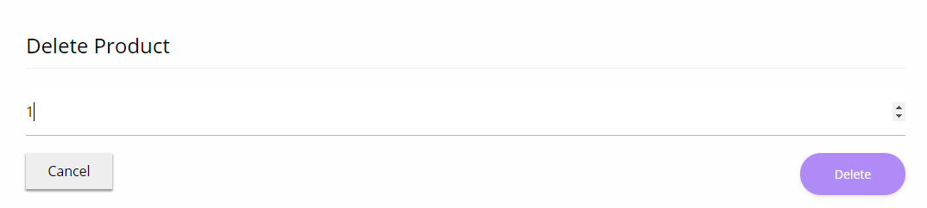

***Fig: delete product form for admin***

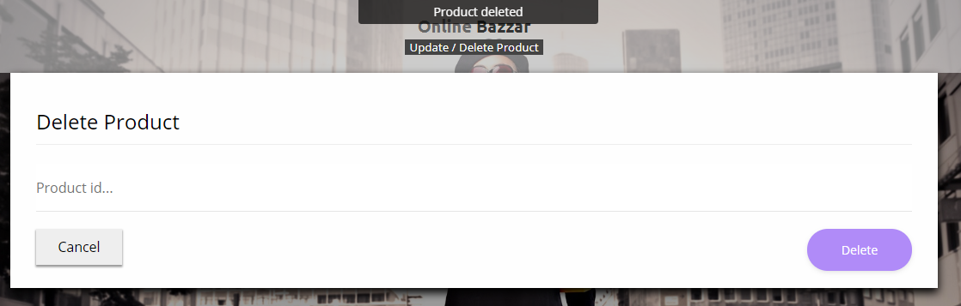

***Fig: product deleted successfully***

**Test case:13**

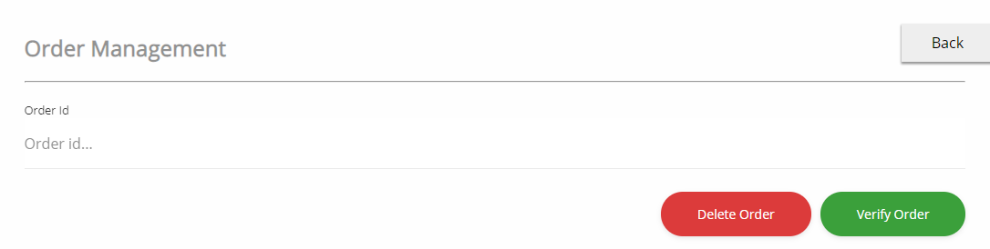

***Fig: order management form***

Here the admin is missing to insert the order id number for verifying order so the order management is unsuccessful.

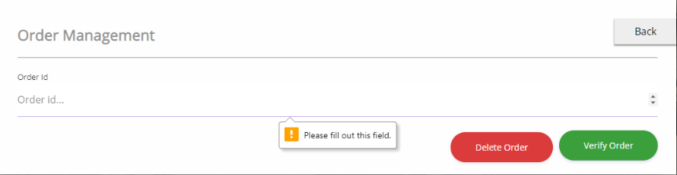

***Fig: message is seen to fill out the field.***

**Test case: 14**

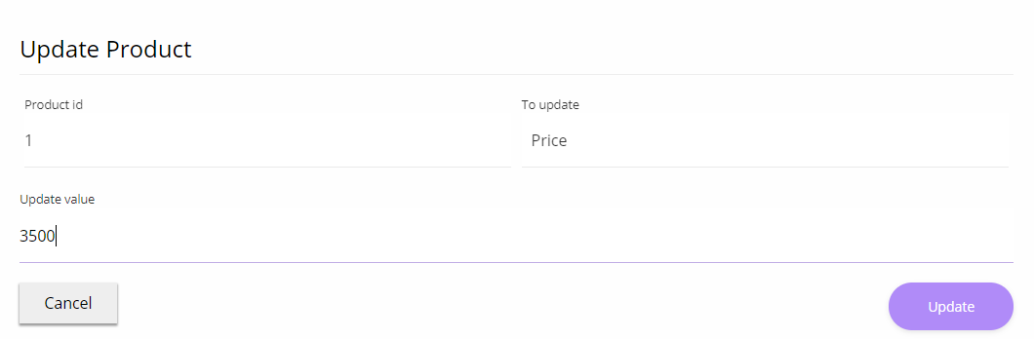

***Fig: product price is updating by admin***

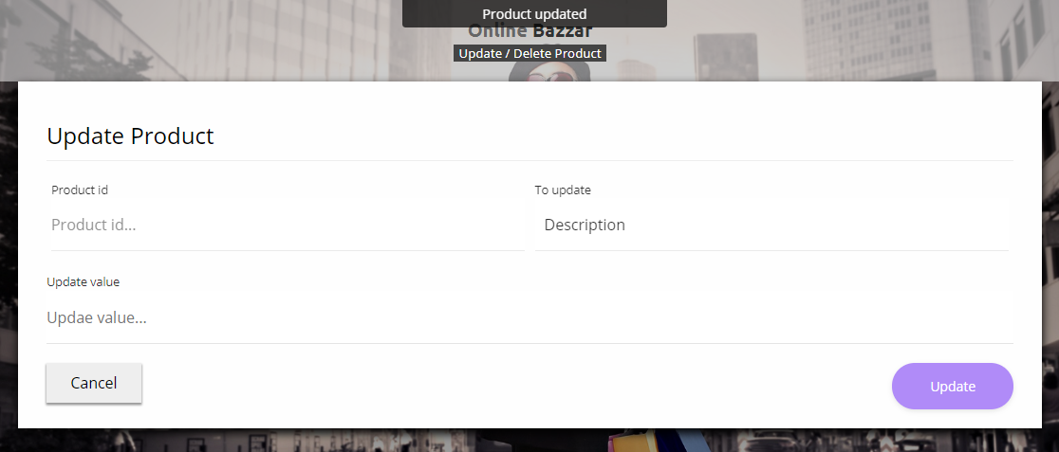

***Fig: price updated successfully***

**Test case:15**

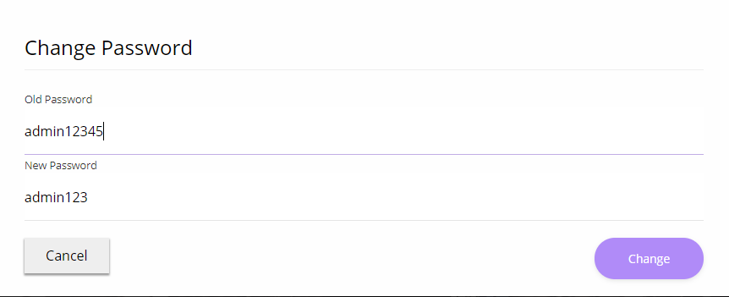

***Fig: password changing for admin***

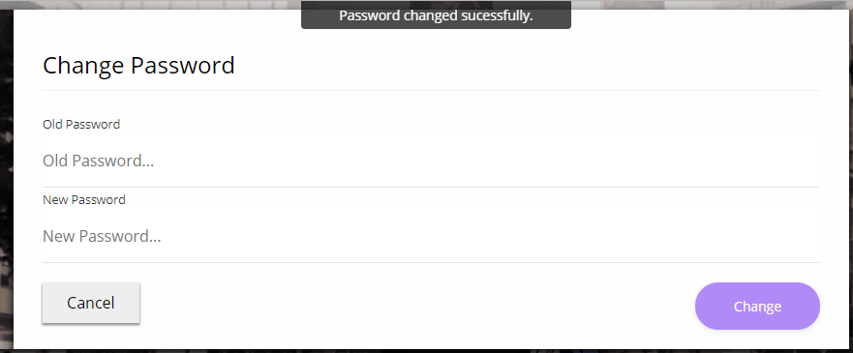

***Fig: password has been changed successfully***

**Test case:16**

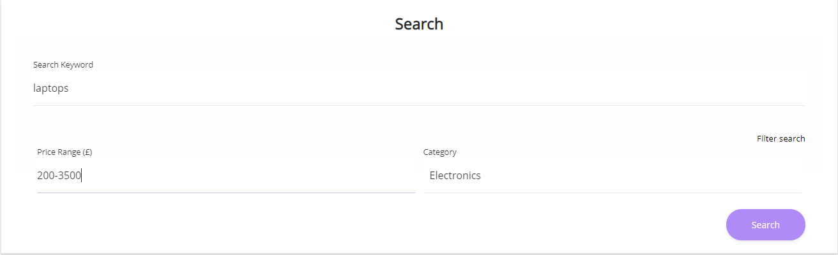

***Fig: searching for product with filling the form completely***

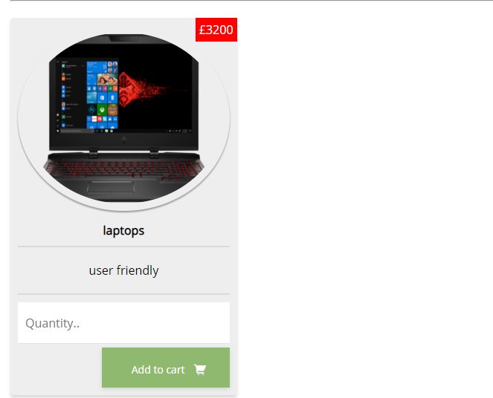

***Fig: product is seen as the customer needed***

**Test case:17**

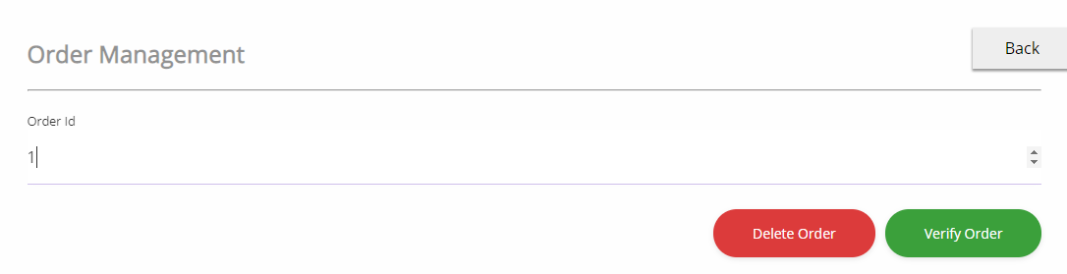

***Fig: Delete order form***

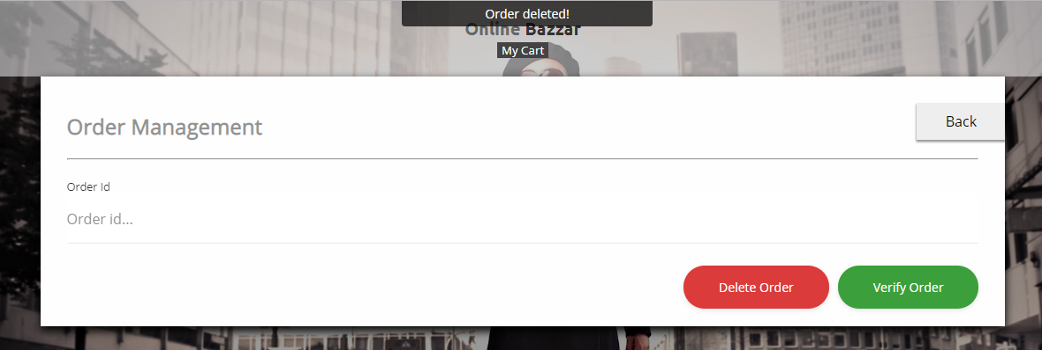

***Fig: Customer order deleted successfully***

**Test case:18**

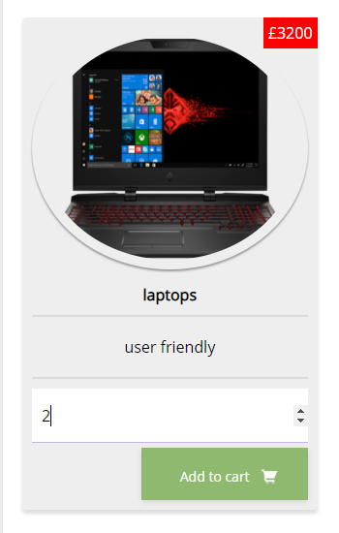

***Fig: Ordering item without login into the system***

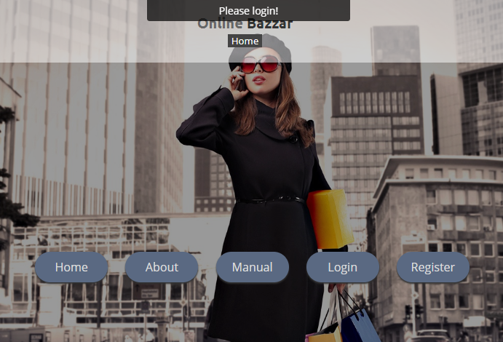

***Fig: cannot order item and a message is seen***

**Test case:19**

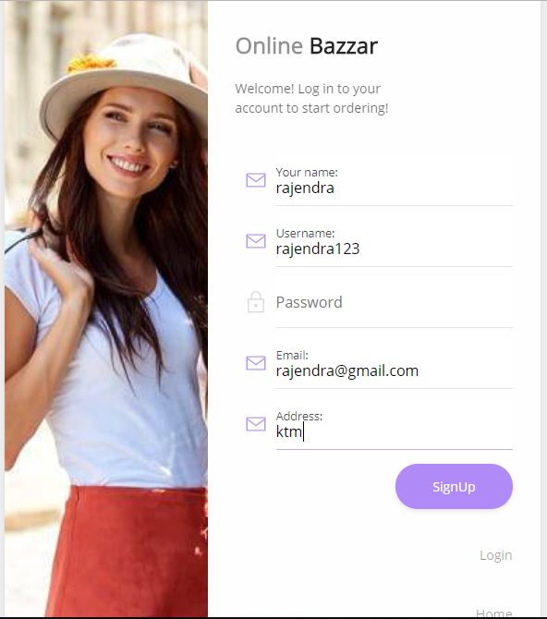

***Fig; Customer registration without filling form completely***

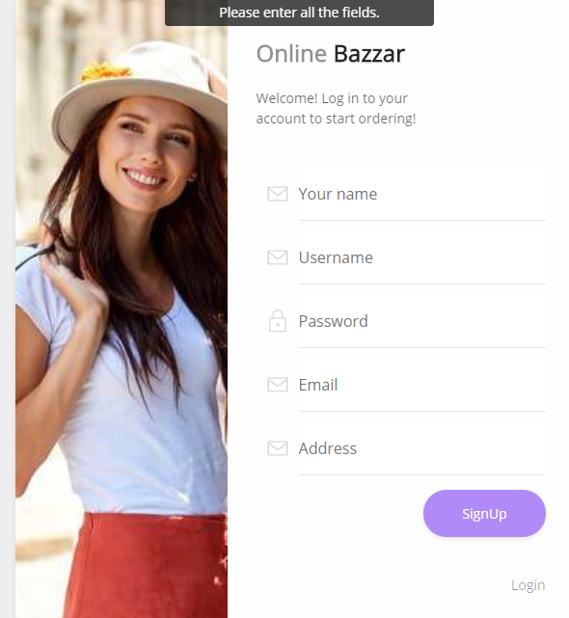

***Fig: Register unsuccessful and message is seen***

**Test case: 20**

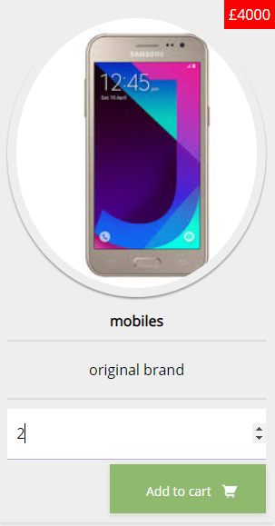

**Ordering product with valid order quantity**

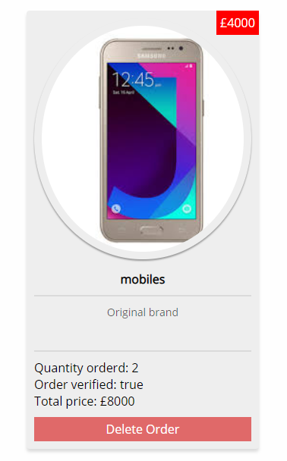

**Order verified successfully.**

* + 1. **Unit testing: -**

It is a software development process which is used to test each and every little testable pieces of the product. Unit testing should be possible physically yet it is frequently mechanized and usually done by the white box testing. The image for unit testing is shown below: -

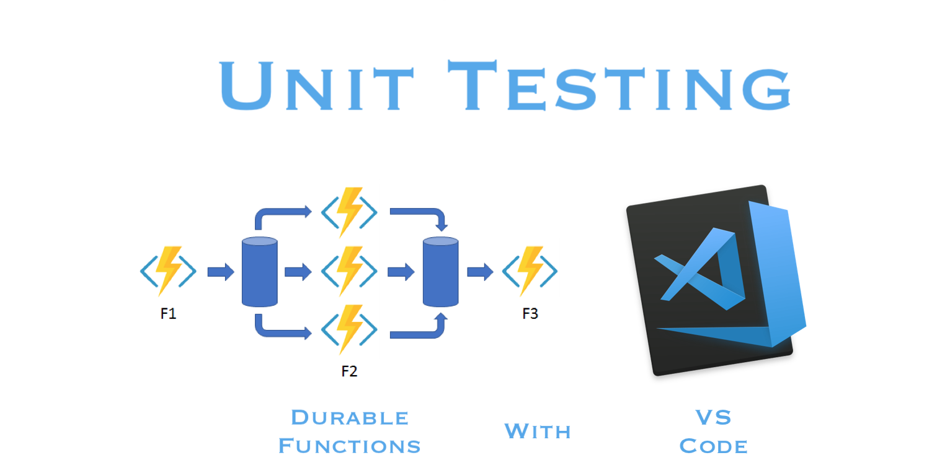

* + 1. **Test plan: -**

Here below there are some activities which has been tested significantly and a document is created. The test case table for unit testing are shown blow: -

**Test case:1**

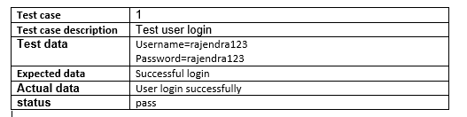

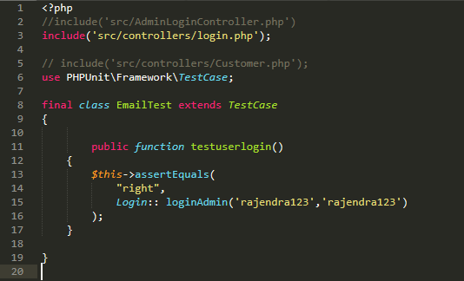

**Fig: Testing user login with username and password**

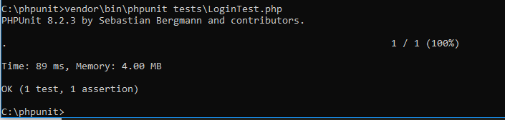

***Fig: User login successful***

**Test case:2**

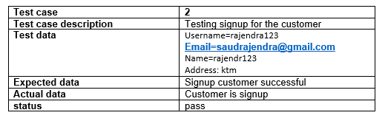

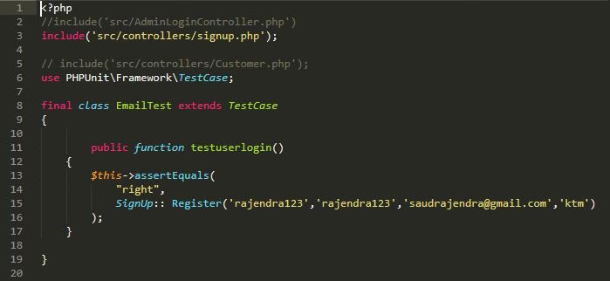

***Fig: Testing signup of the customer***

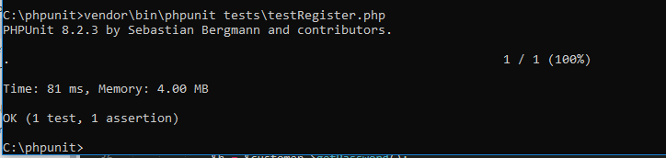

***Fig: signup for customer is successful***

**Test case: 3**

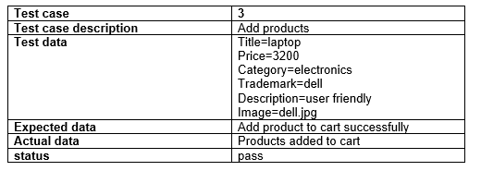

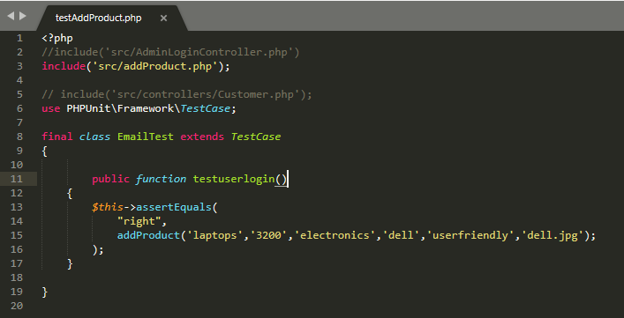

***Fig: testing add products***

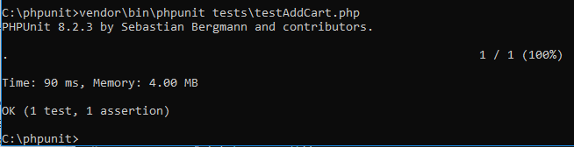

***Fig: product added to cart successfully***

**Test case: 4**

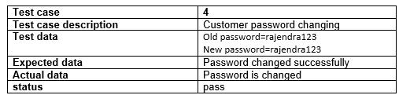

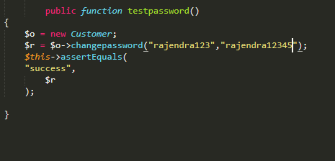

***Fig: testing customer password changing process***

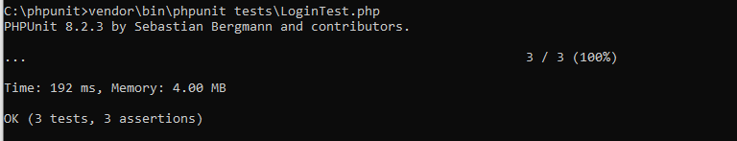

***Fig: changing password successful***

**Test case:5**

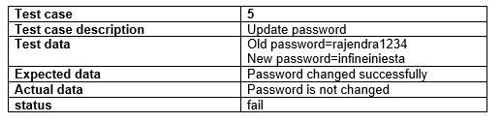

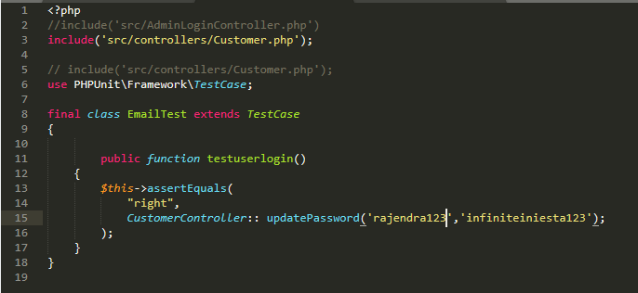

***Fig: testing customer password updating***

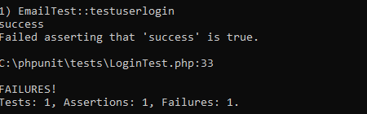

***Fig: password updating failed***

# Chapter 6: Other project issues

**6.1 Risk** **Assessment**

While developing any project various issues, obligations, challenges and losses are occurred due to internal and external vulnerability and leads towards undesirable outcomes which is usually called as risk. It is also known as a difficulty in which organization have to consider the time and losses towards project development. Risk management is necessary to manage and identify possible risks earlier for successful development of the project.

Basically risk management can be defined as the activity to identify the common threats that can be arise over organization budget and resources. There are three basic steps for risk management which are defined below: -

* Identification of possible risks: -

It is the initial stage in risk management process in which the common threats against system developments are identified.

* Analysis of possible risks: -

It is usually known as second stage on risk management process in which the possible identified risks are analyzed first and then the results are concluded to arranges the threats.

* Controlling over possible risks; -

The analyzed results are fulfilled in this step through managing the risks and control over them for developing successful product.

Likewise, in this product development there will be some portions of risks factors which must be investigated for better outcomes

The method for calculating risk management impact = likelihood*Consequences

The choices for risk likelihood are listed below in tables: -

|  |  |
| --- | --- |
| **Likelihood** | **Values** |
| Low | 1 |
| Medium | 2 |
| High | 3 |

The five choices for the consequences are listed below in tables: -

|  |  |
| --- | --- |
| **Consequences** | **Values** |
| Very low | 1 |
| Low | 2 |
| Medium | 3 |
| High | 4 |
| Very high | 5 |

The risk consequences values are shown below in tables: -

|  |  |  |  |  |  |
| --- | --- | --- | --- | --- | --- |
| **SN** | **Risks** | **Likelihood** | **Consequences** | **Impact** | **Actions** |
| 1 | Failure of Hardware | 3 | 3 | 9(3*3) | Proper maintenance is done |
| 2 | Natural disaster | 1 | 3 | 3(1*3) | Backup for files |
| 3 | DDOS attack | 2 | 3 | 6(2*3) | Powerful server should be used. |
| 4 | Theft or robbery | 2 | 3 | 6(2*3) | Password protected or backup are necessary. |
| 5 | Failure in the time schedule | 2 | 4 | 8(1*3) | Proper planning is necessary. |
| 6 | Project requirements may not be found easily. | 3 | 1 | 3(1*3) | Looks for various websites and can take a guide from seniors and teachers. |
| 7 | Insufficient skills | 1 | 3 | 3(1*3) | Various project related training should be provided to develop the skill. |

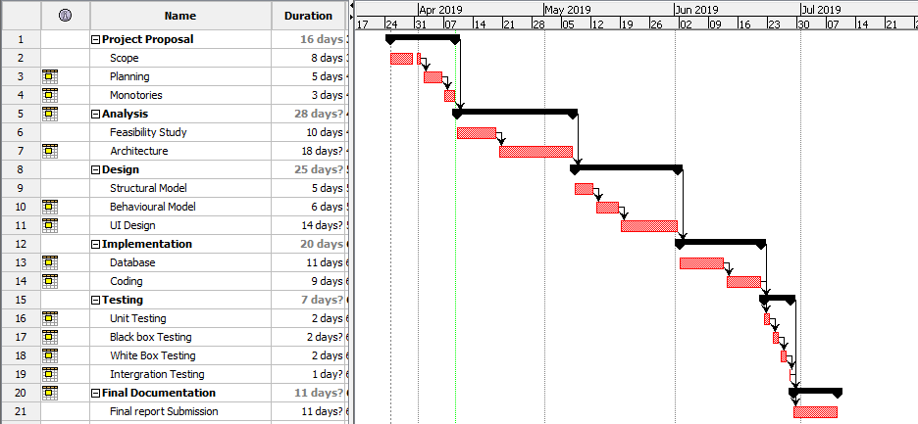

Fig: Gantt chart for system development.

**6.2 Configuration management**

It is the process which facilitates to identify, oversee, arrange and have control over the records which has been changed systematically while developing a project. It aims to enhance product functionality considering the various mistakes and the product is developed within fixed budget and time.

**6.2.1. Version Control**

while developing a project it works as a software tool through which the various changes within codes can be managed on remaining timespan limit. It provides tendency to developers for tracking each and every modified series of codes and facilitates to provide the strategy of returning back to earlier stages for fixing various issues and bugs considering the time and cost of the project.

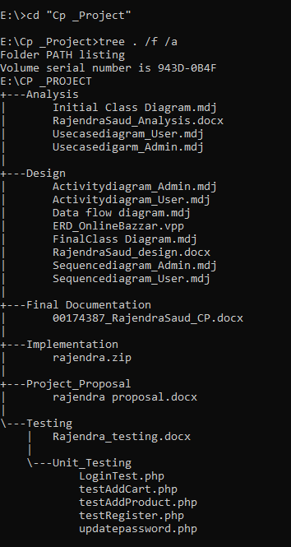

**6.3. Future work: -**

Here, we can expect a system “Online Bazzar” is completely developed by considering the needs and features required for better business visionary but still there are some functional and non-functional requirements which may not be fulfilled because of time constraint and added to the future work which can be developed on coming days. They can be listed as following; -

* Facilitating customers through online payment on purchasing
* Customer care services and feedback box.
* Concerning system security.
* Cookie notification while customer login.

**6.4. User manual: -**

After the successful deployment of the product in market various customers wants to access the system focusing the unexperienced and new customer’s user manual are developed to have a proper guidance on accessing the system. Some of the points are described below on focusing user manual towards system: -

* Customer Signup: -

It is necessary for customer to sign up the account in case for successful login into the system. Otherwise the individual will be unable to order required item so customer can sign up the system by: -

1. By clicking on register button which is seen in home page of the system.
2. Then fulfilling the registering form requirements, they can have login to the system.

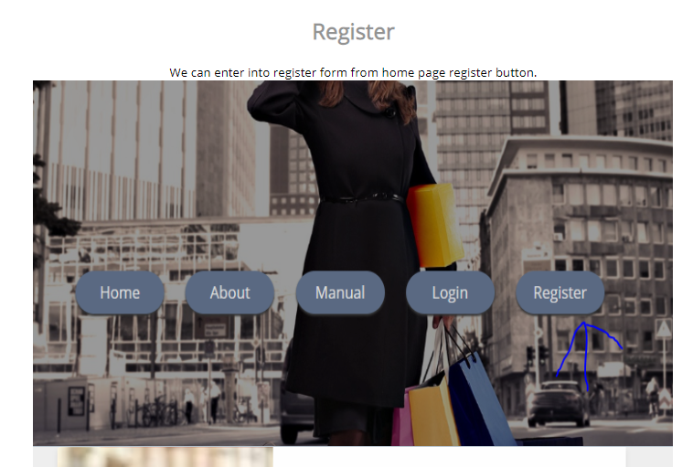

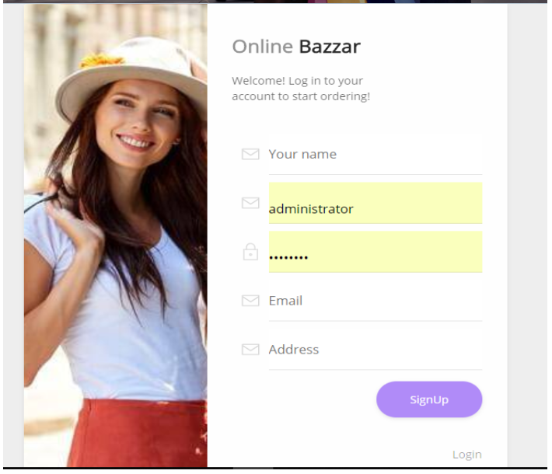

By clicking signup, button the process will be successful.

* **For signup customers: -**

After signup has been completed successfully then customer will direct towards login form and login into the system by:

1. Providing the correct username and password which is set at the time of registration
2. By simply clicking on login form they can access the system.

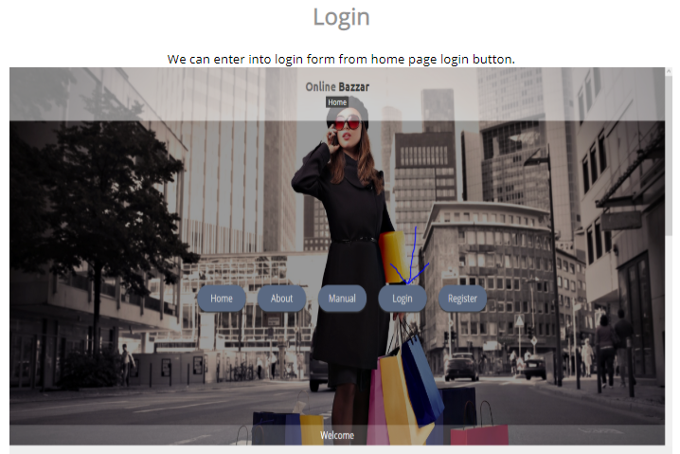

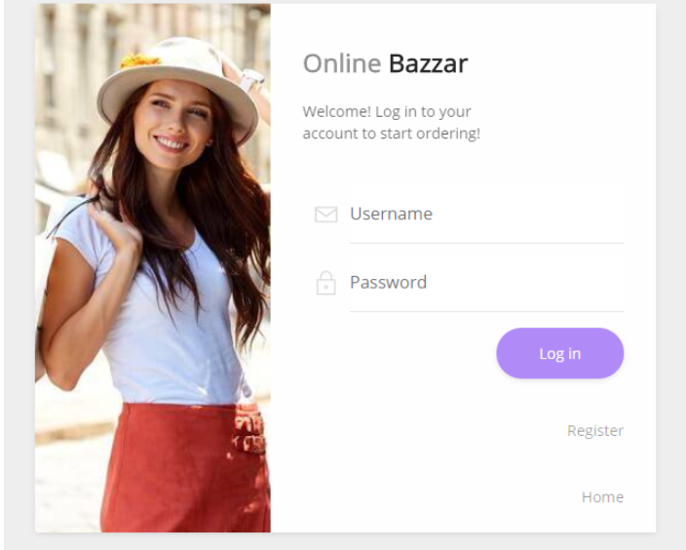

By simply clicking login the system is access to customer.

* **Searching products: -**

After successful login of the customer is directed towards dashboard and if wanted to search the item by:

1. Filling the product search form completely and by clicking search the product will be seen.

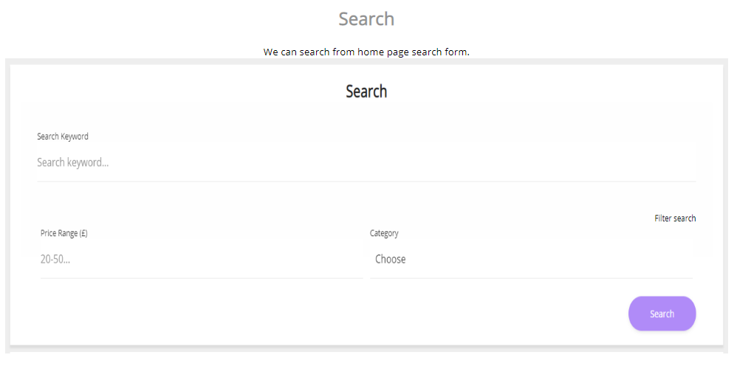

By simply clicking on search result for product will be seen.

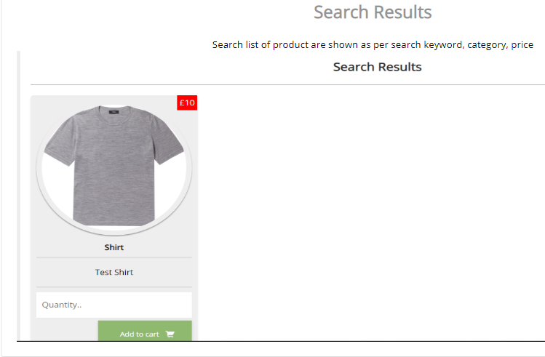

* **Ordering product: -**

After the search result completed and wants to order item they can do:

1. By selecting the product quantity, they needed and simply clicking on add to cart then product is ordered.

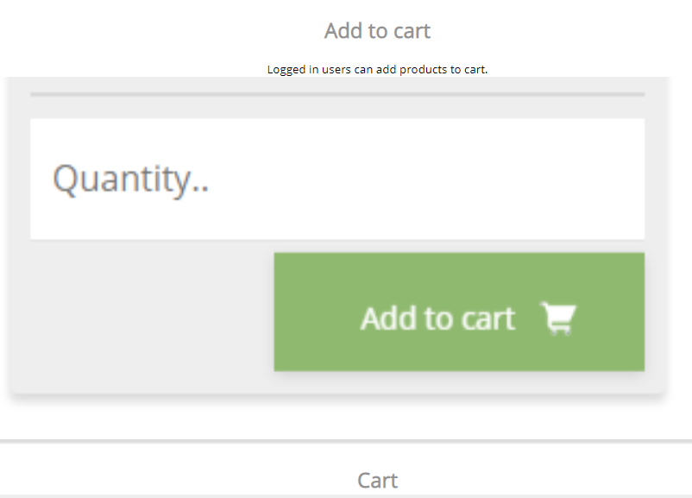

By clicking the button add to cart product is ordered.

* **Delete order: -**

If they do not need the item they can delete the order by: -

1. Simply clicking the button delete order then the product order will be deleted.

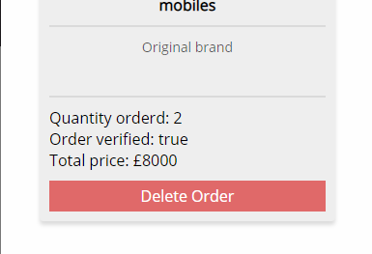

By clicking the button product will be deleted

* **View order: -**

If the customer wants to view their order, then customer can simply click the button my cart and can see their order.

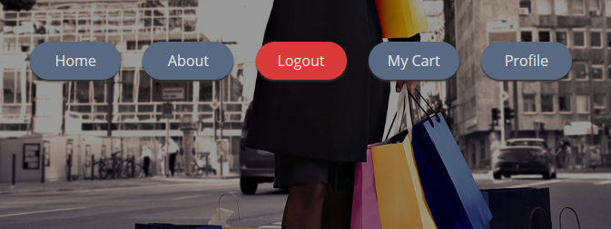

By clicking on my cart button product ordered will be seen.

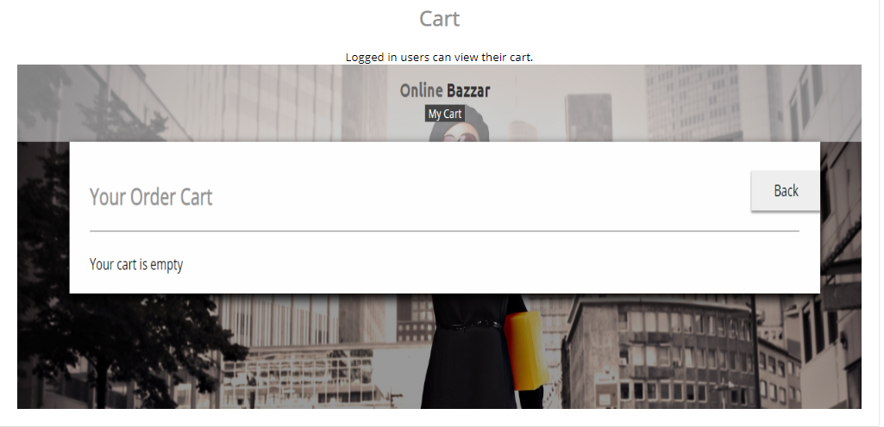

**6.5. Limitations of the project: -**

The following points are some limitations of the project: -

* It does not facilitate the customer by providing online payment system.
* Lack of some additional features in the system which makes the system usability more robust.

# Chapter 7: Project Conclusion

The system “Online Bazzar” which is a commercial site for facilitating their customer is successfully developed. It will help the customer by providing user friendly features and is highly reliable. Where customer can order the items they needed from anywhere else and facilitates them to view their cart and delete the order in case of not necessary. Here admin can add, update and delete products and additionally view the number of customers and can manages their orders. The product is developed within timespan limit by considering project schedule and designed are developed considering MVC design pattern and method of SDLC is implemented in the system.

# Chapter 8: Appendix

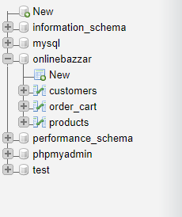

Fig: Online Bazzar MYSQL tables

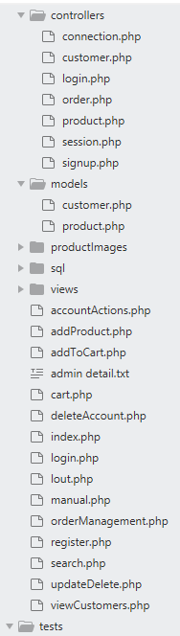

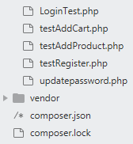

Developed project folder

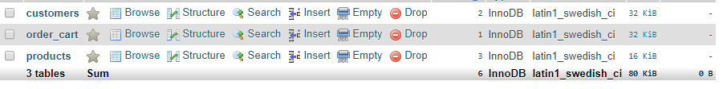

Online Bazzar Database tables

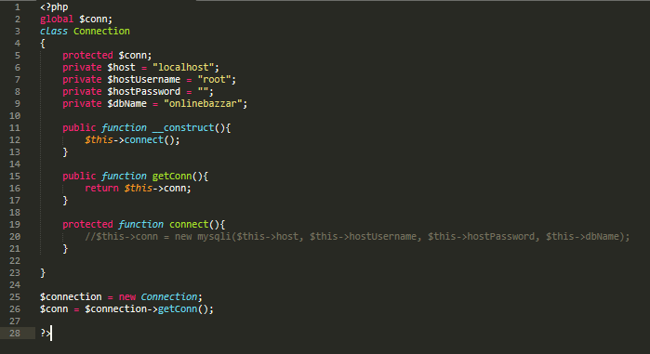

Fig: Sql connection for system

Signup design

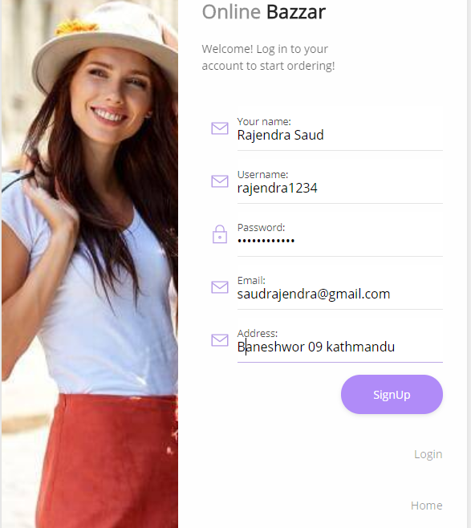

Signup codes

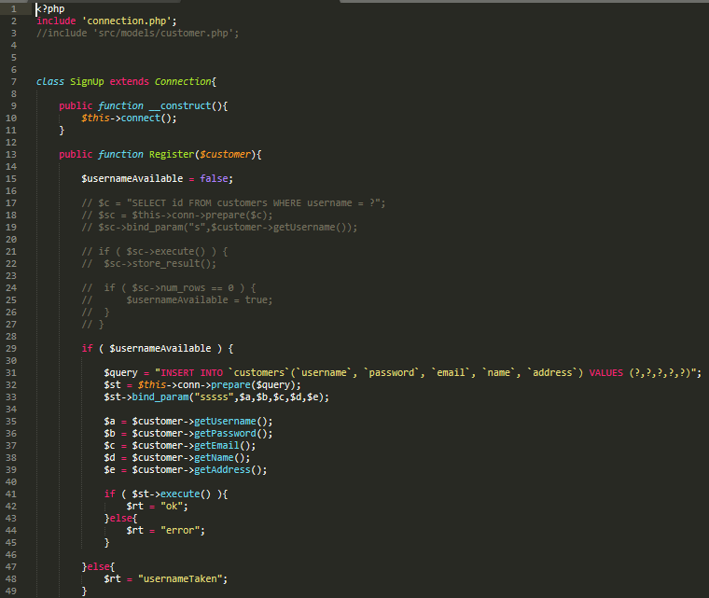

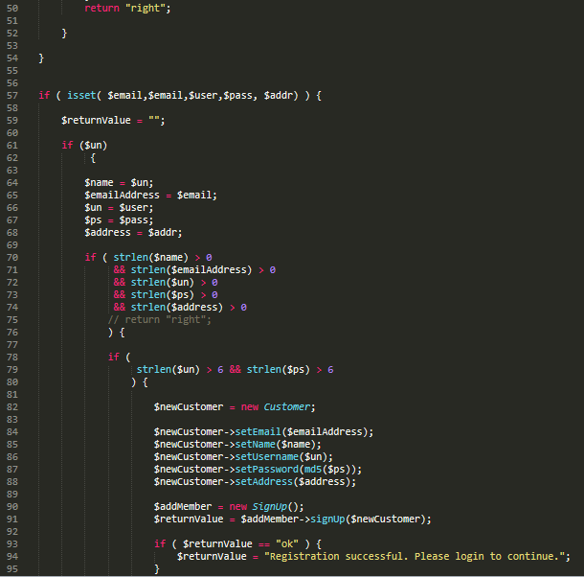

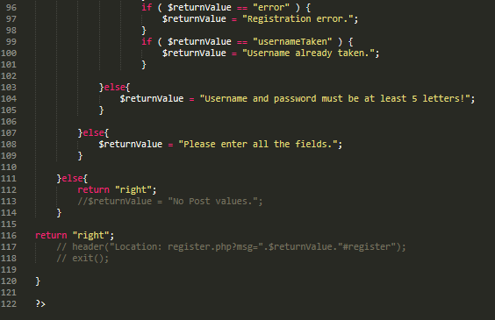

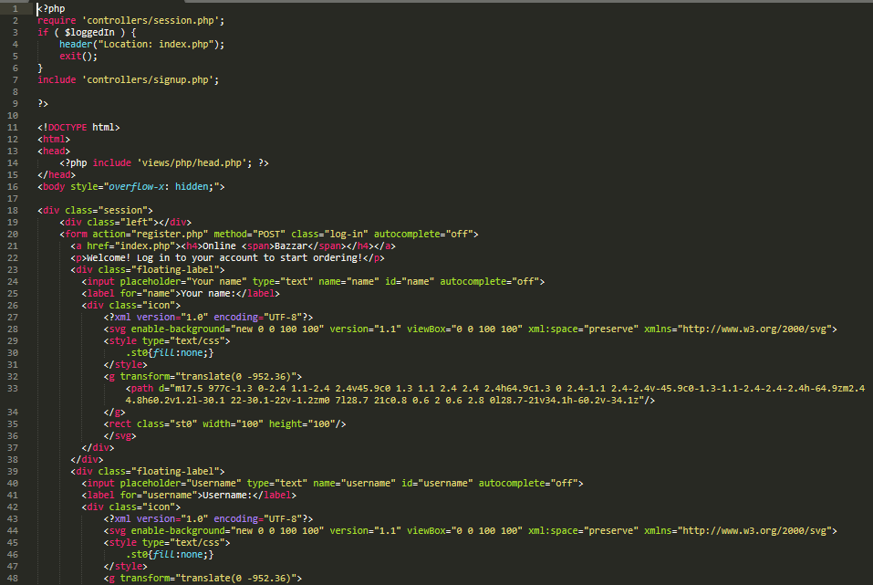

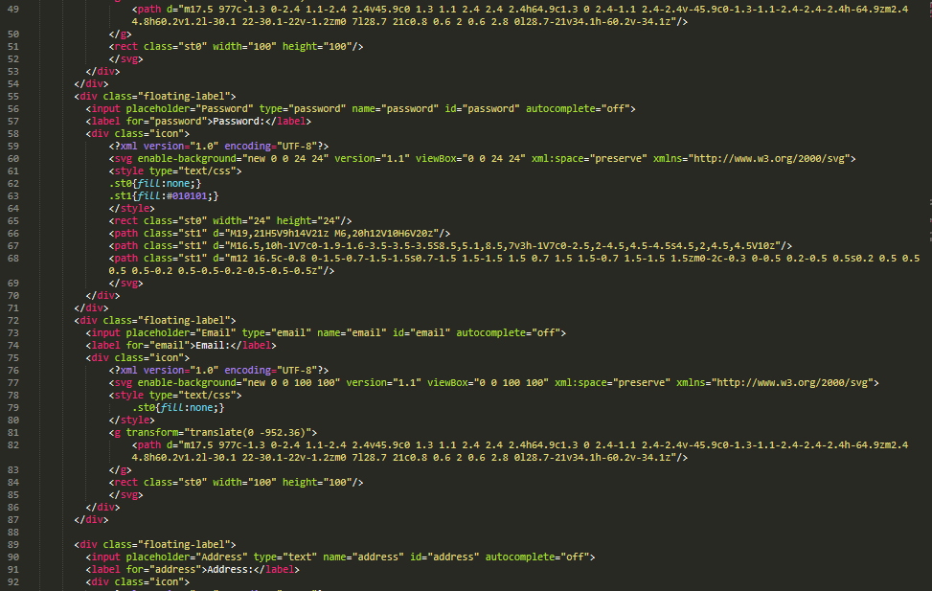

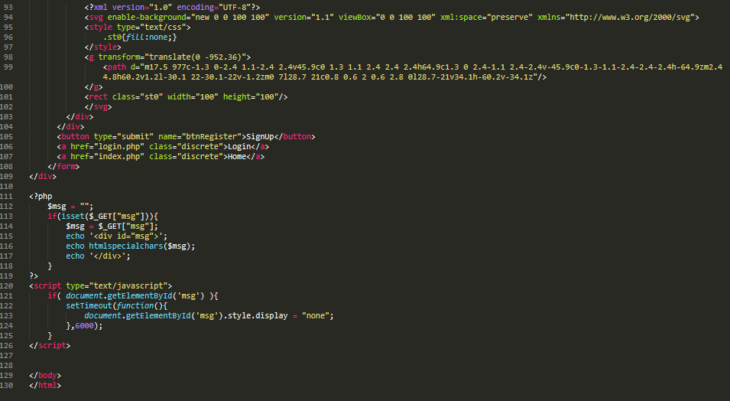

Login design

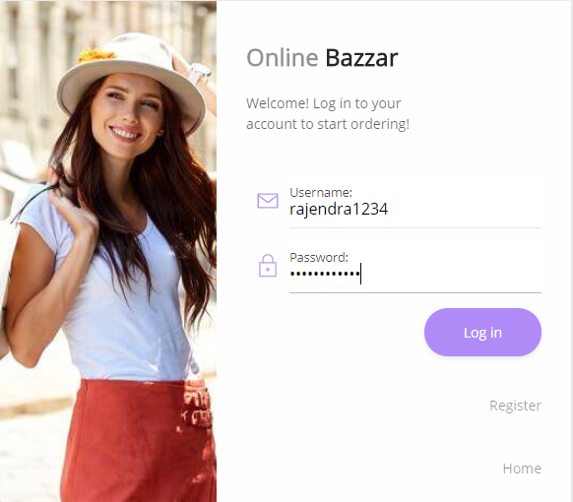

Login codes

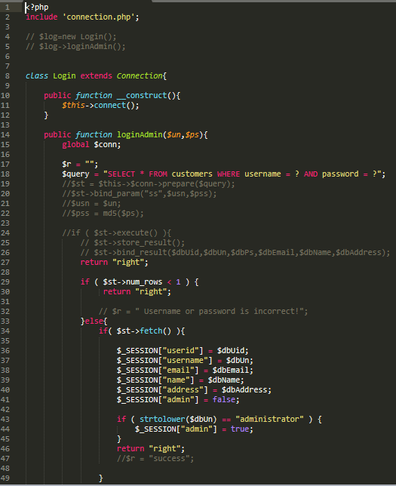

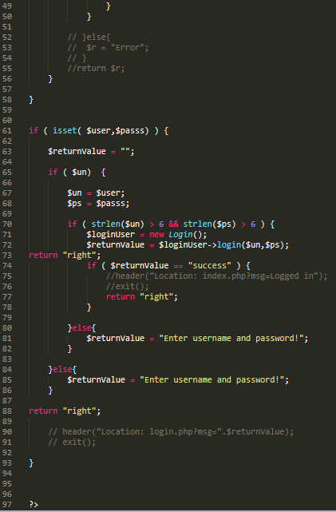

Search product design

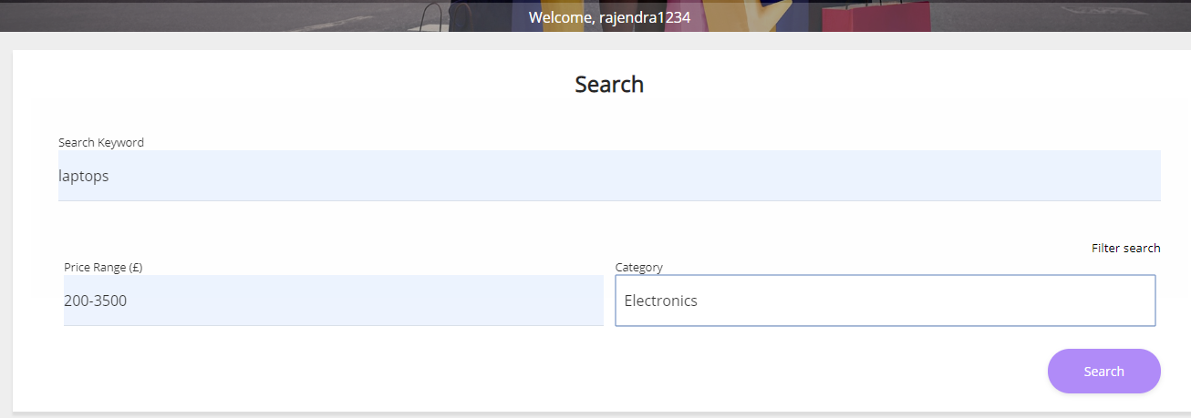

Search product codes

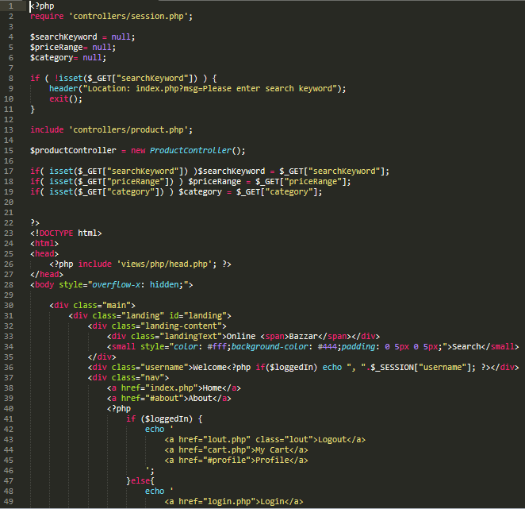

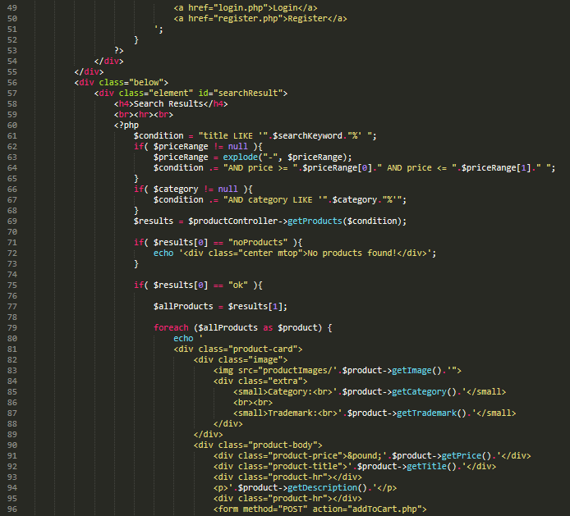

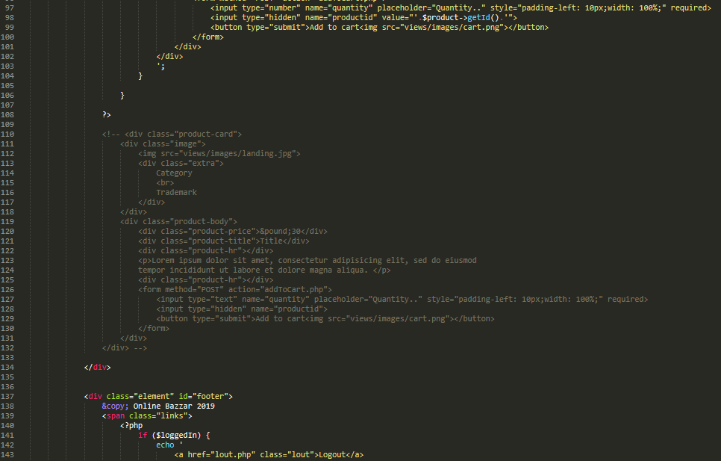

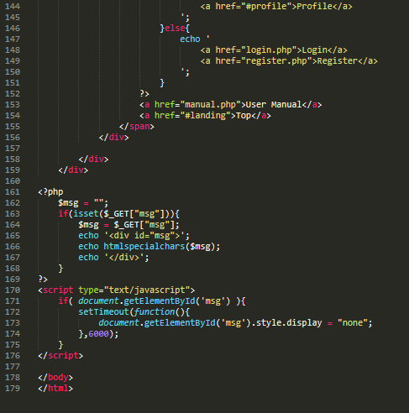

Add to cart design

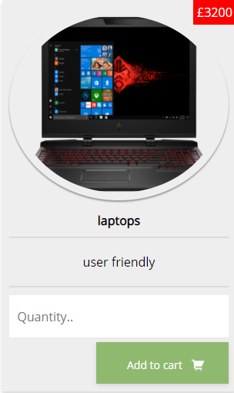

Ordered cart design

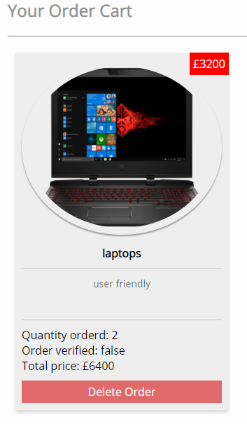

Delete order

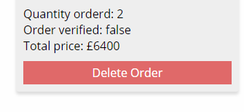

codes

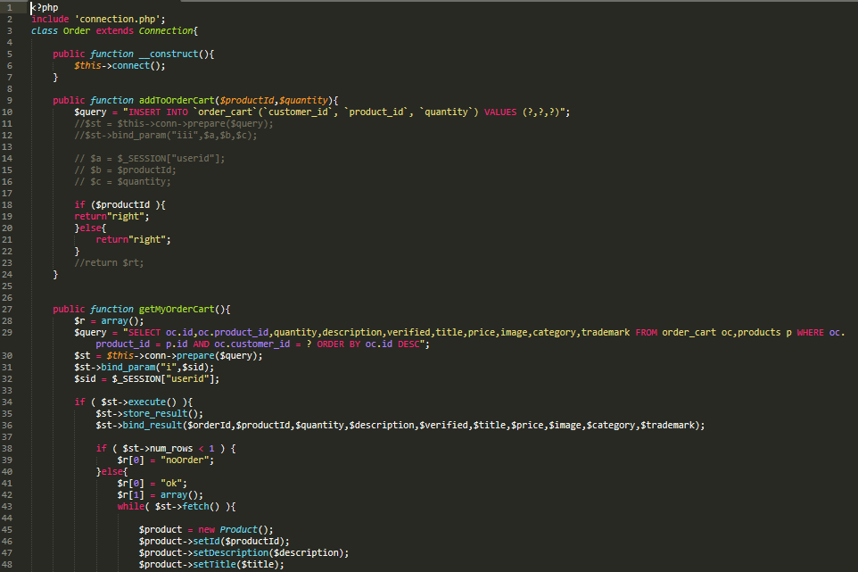

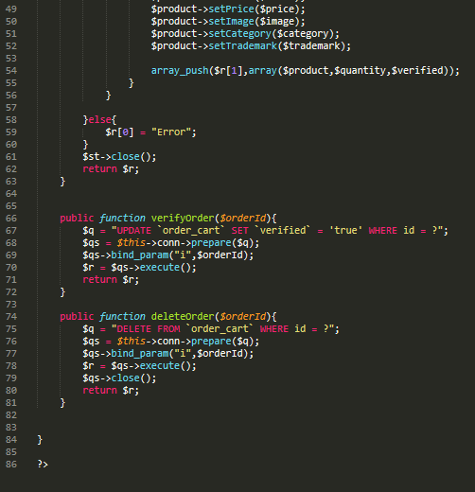

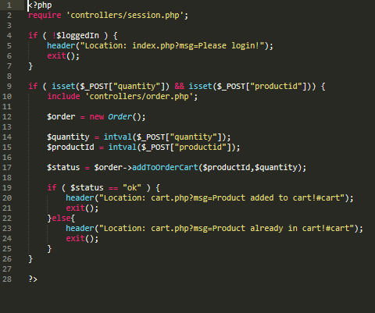

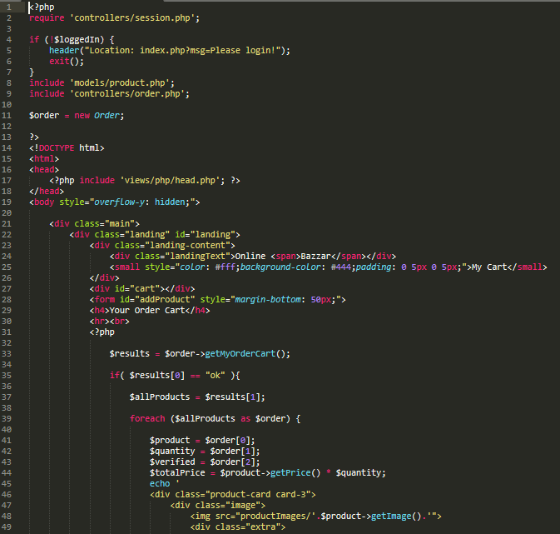

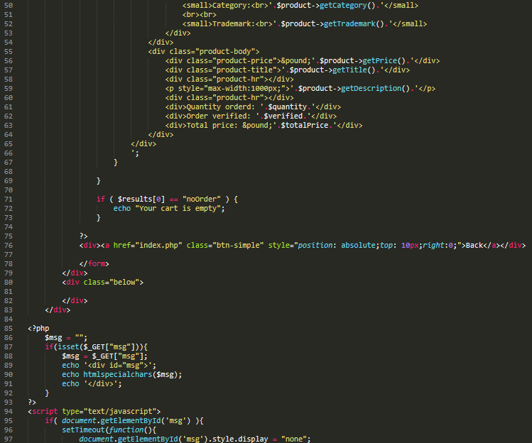

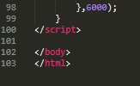

Customer actions design

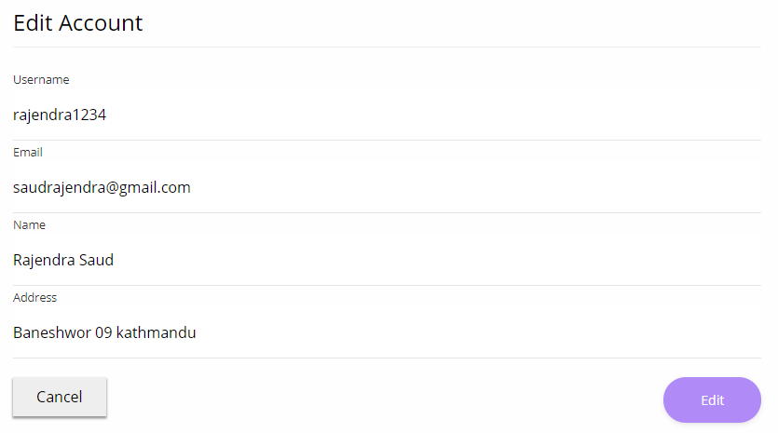

Fig: Edit account design



Fig: Deleting account of customers

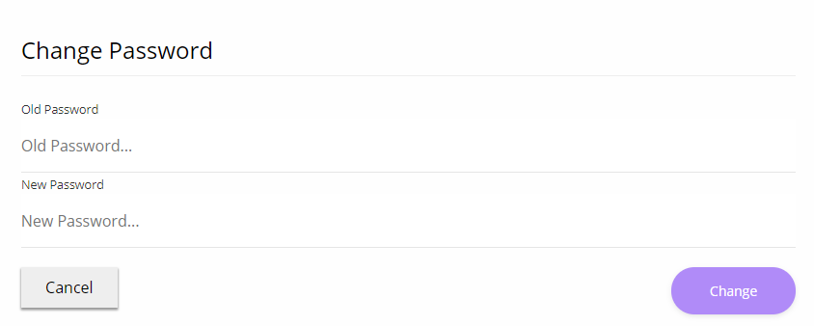

Fig: password changing design

Customer action codes

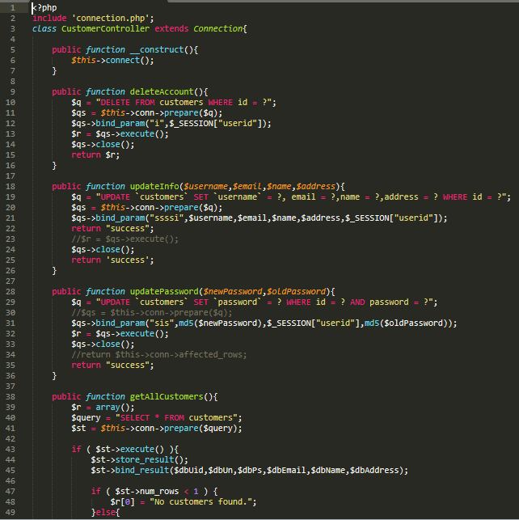

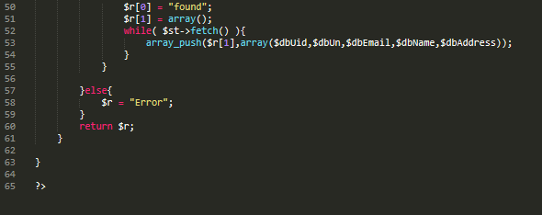

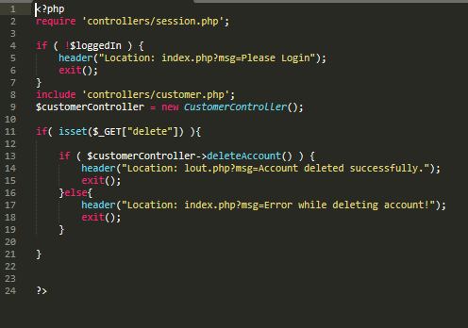

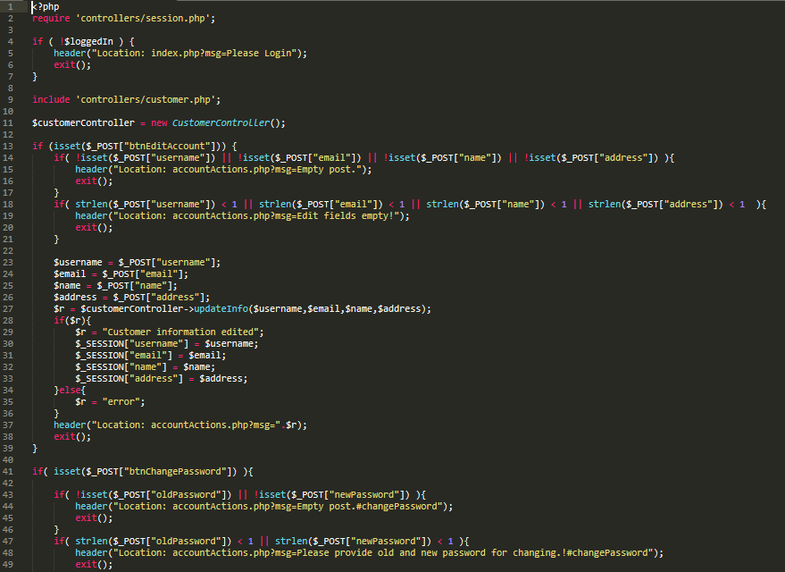

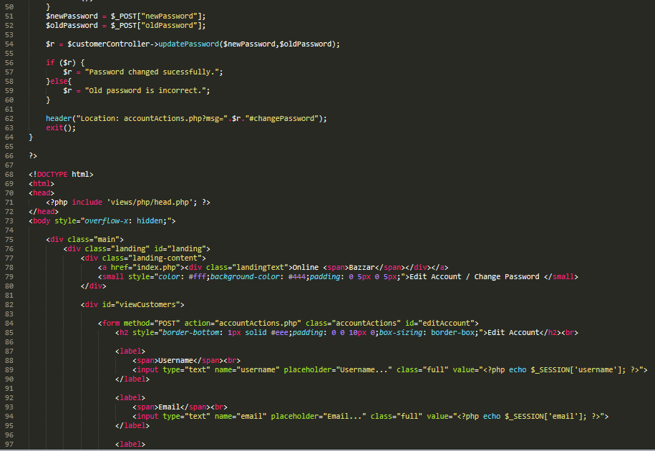

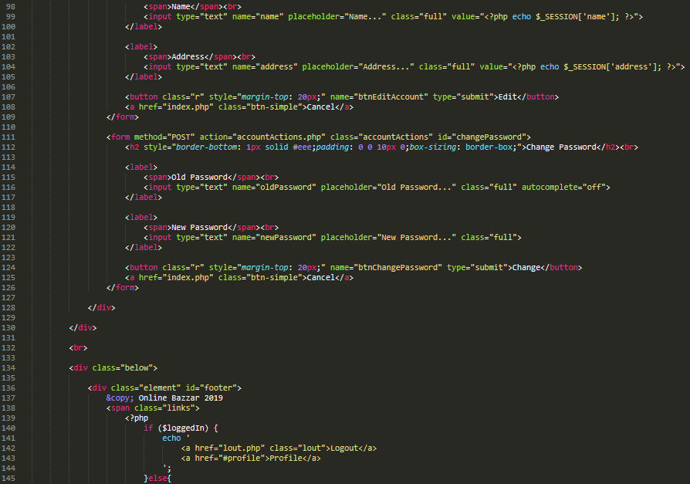

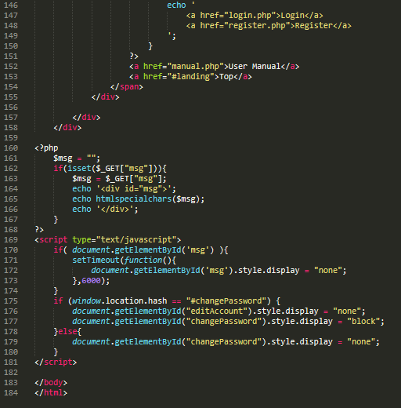

Admin dashboard

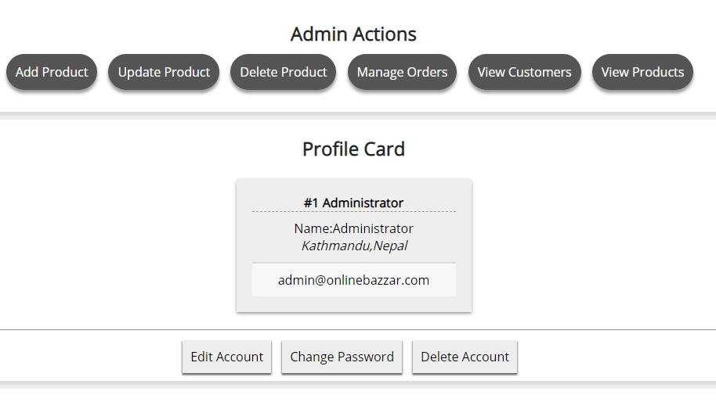

Add product design

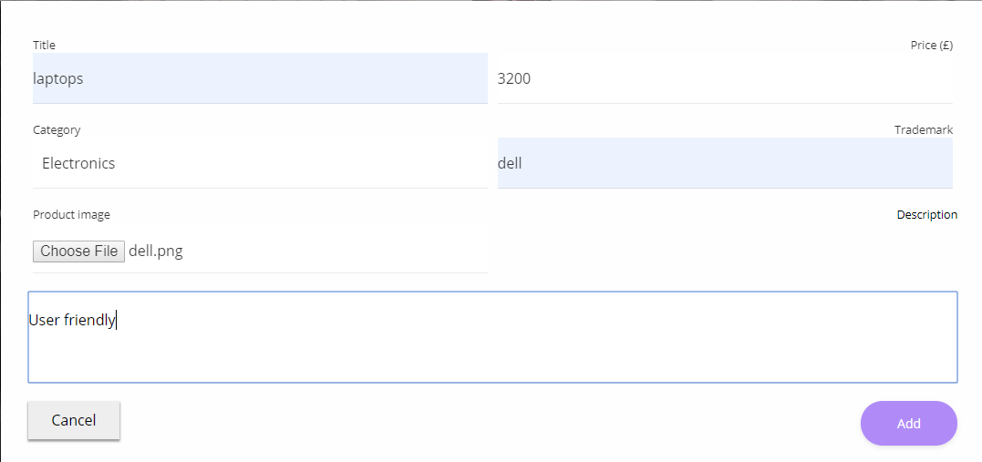

Codes

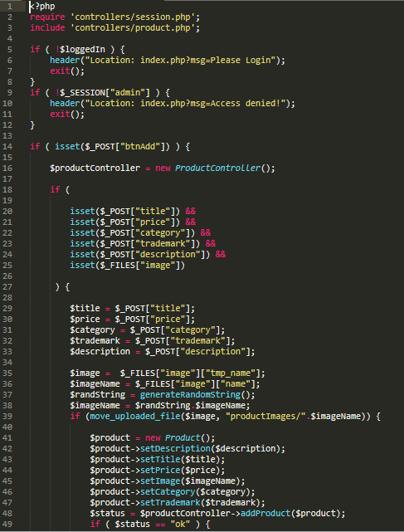

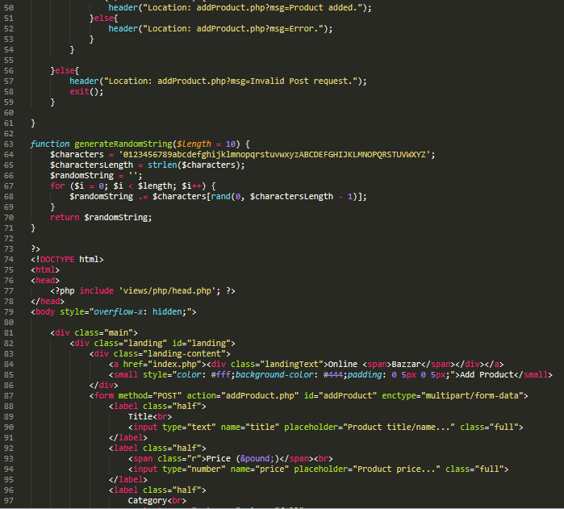

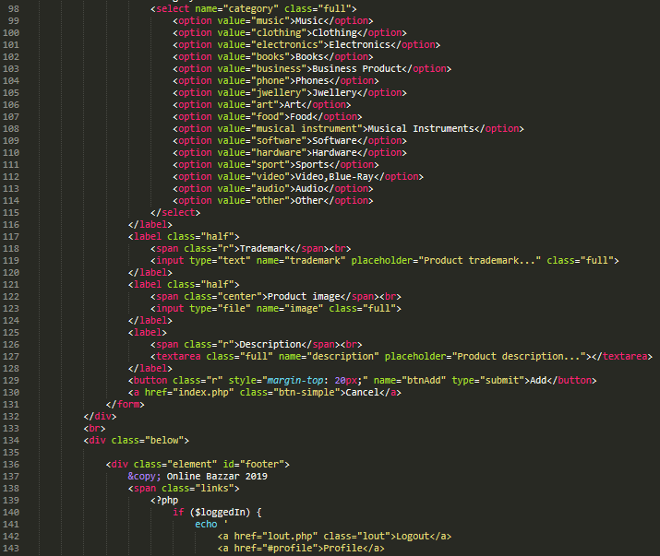

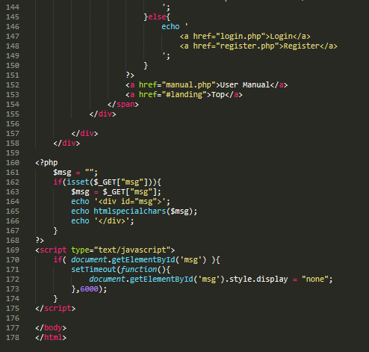

Update product design

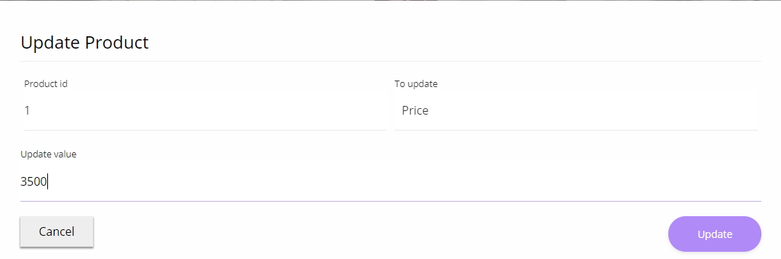

Delete product

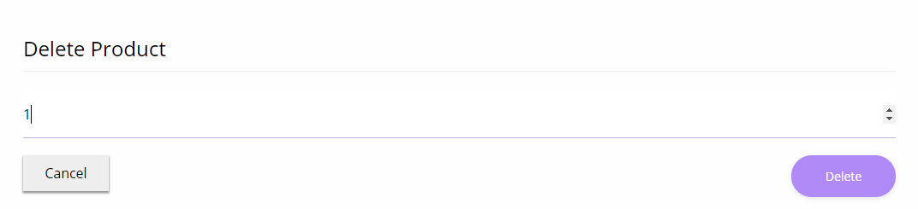

Codes

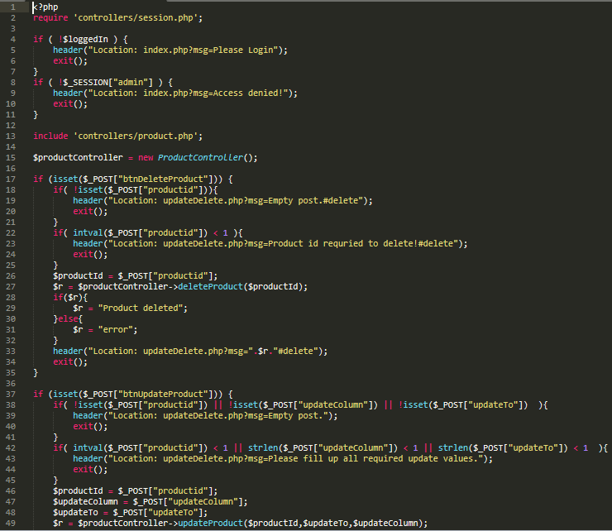

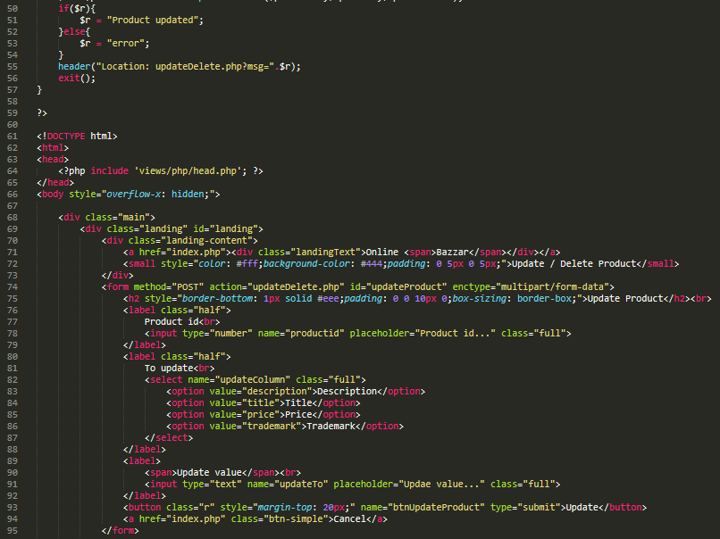

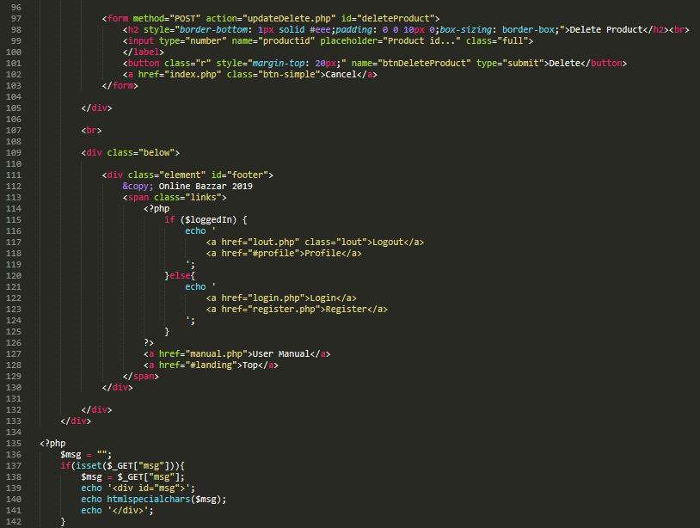

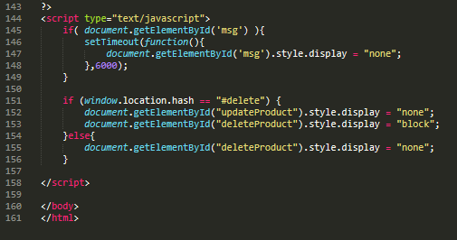

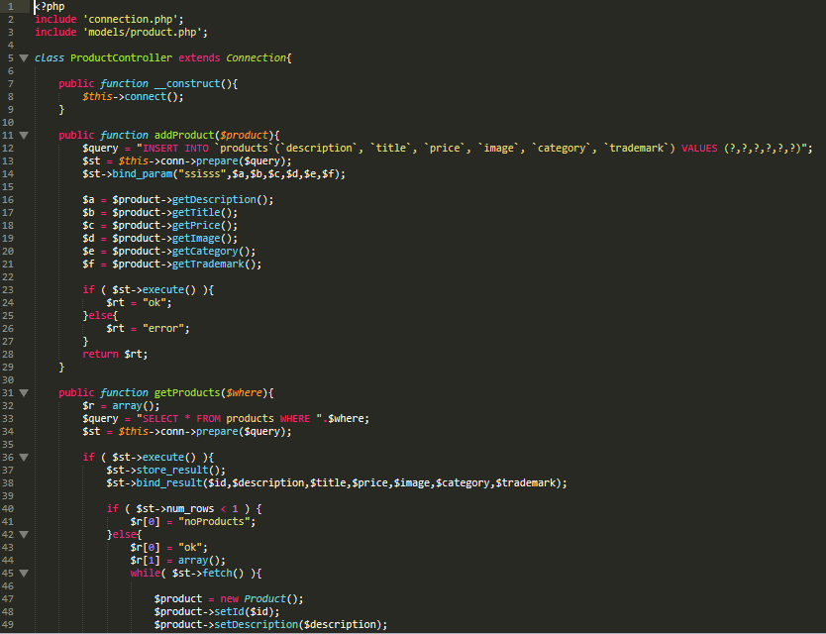



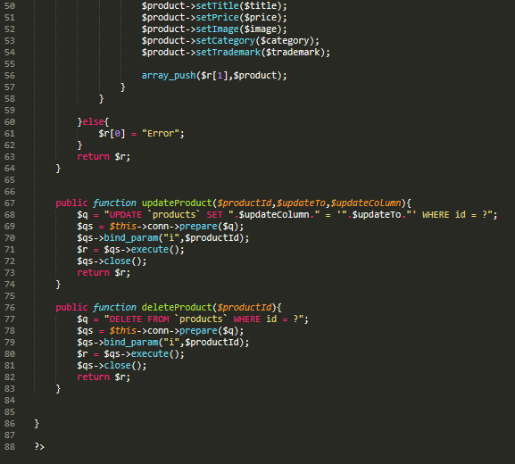

Manage orders design

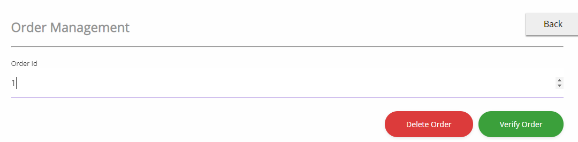

Codes

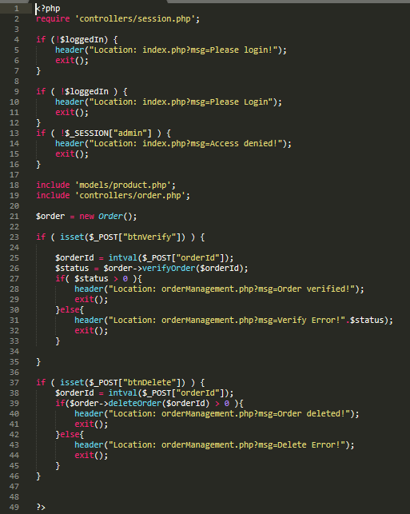

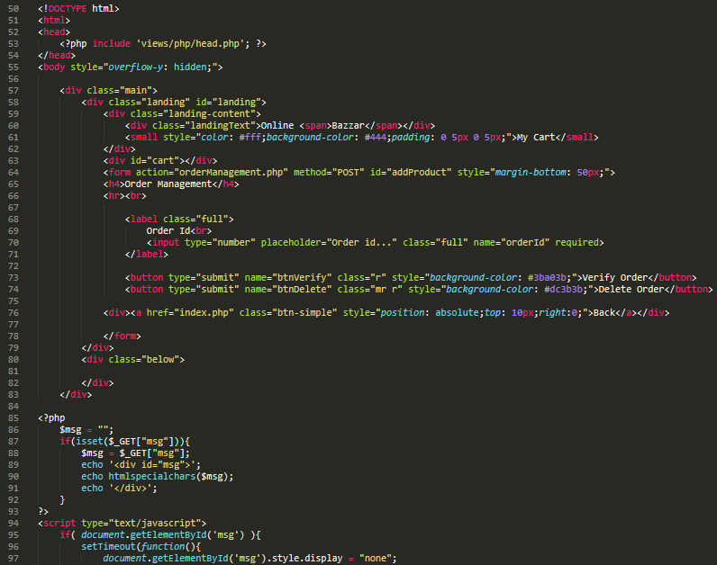

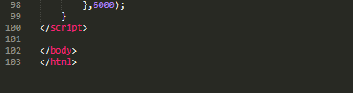

View customers design

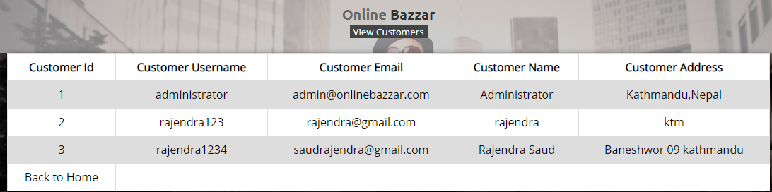

Codes

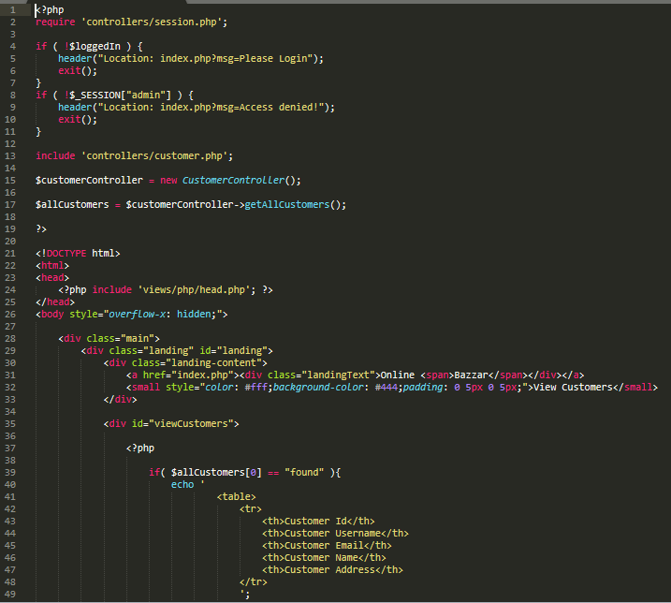

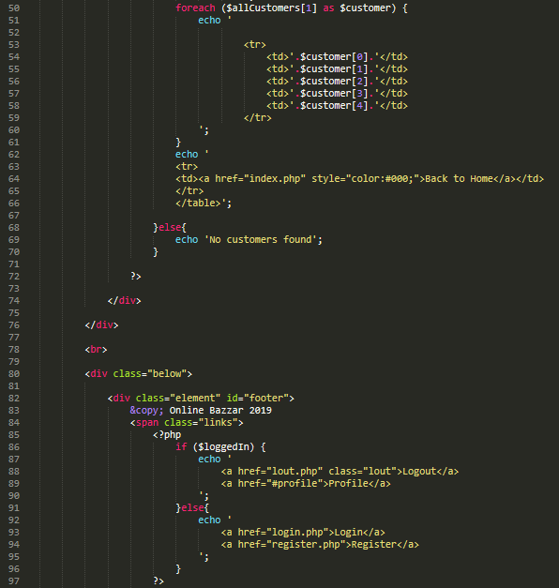

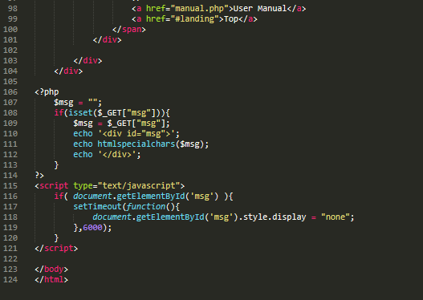

Logout Codes

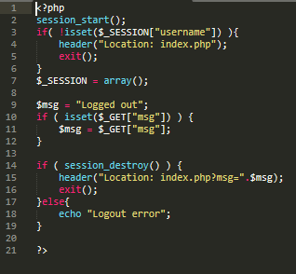

When logout

